Prep = 25 marks

1. Sperry’s ‘split brain’ study investigated the psychological effects of hemisphere deconnection. Describe what is meant by the term ‘hemisphere deconnection’. [2]
2. Give **one** reason why the participants had previously undergone an operation to deconnect the two hemispheres of the brain. [2]
3. Outline **one** problem with generalising from the sample used in this study. [2]
4. Explain why Sperry’s study is a natural / quasi experiment. [2]
5. From Sperry’s ‘split brain’ study, describe how visual stimuli were presented to participants in this study. [4]
6. Explain why patients could not identify in words material presented to their left visual field (LVF). [2]
7. From Sperry’s ‘split brain’ study into the psychological effects of hemisphere deconnection:
8. Describe **one** finding from the visual tests used in this study. [2]
9. Describe **one** finding from the tactile tests used in this study. [2]
10. Describe **one** finding from the composite word tests used in this study. [2]
11. Summarise Baron Cohen’s Core Study into 5 marks worth of material (aim, sample, procedure, results, conclusions). [5]

**Jan 2009: Questions**

9. The study by Sperry investigated the psychological effects of the hemisphere deconnection in split brain patients.

1. Describe how split brain patients responded to visual material presented to their right visual field (RVF). [2]
2. Outline **one** conclusion from this study. [2]

**Answers**

9 (a)

Patients were able to describe the materials in speech and writing

**9 (b)**

As participants were able to describe in speech and writing images flashed to their RVF which is linked to the left hemisphere, one can conclude that language skills are based in the left hemisphere of the brain.

**June 2009: Questions**

7. From Sperry’s split brain study:

1. Identify **one** difference between ‘split brain’ patients and ‘normal’ people in their ability to identify objects by touch alone. [2]
2. Outline one reason for this difference. [2]

**Answers**

**7 (a)**

One different in ‘split brain’ subjects is that they can only identify objects using the hand that is controlled by the same hemisphere that the information is presented to. However, ‘normal’ people are able to identify objects by touch using both hands and both are able to recognise and identify the object.

**7 (b)**

One reason for this difference is that ‘split-brain’ subjects have had the bundle of nerves that connects the two hemispheres of the brain (the corpus callosum) served, so information is unable to pass from one hemisphere to the other.

**January 2010: Questions**

**8.** Sperry’s ‘split brain’ study investigated the psychological effects of hemisphere deconnection.

1. Give **one** reason why the participants had previously undergone an operation to deconnect the two hemispheres of the brain. [2]
2. Outline **one** problem with generalising from the sample used in this study. [2]

Answers

**8 (a)**

They had crippling epilepsy which could not be cured by drugs. **8 (b)**

One problem with generalising from the sample in this study is that the sample is not representative of the population and therefore the results cannot be generalised because due to their illness hey could have had defects in their brain, different from everyone else’s.

**June 2010: Questions**

9. The study by Sperry investigated the psychological effects of hemisphere deconnection in split brain patients.

1. Describe what is meant by the term ‘hemisphere deconnection’. [2]
2. Identify **one** way hemisphere deconnection affected Sperry’s participants when they were presented with stimuli to one visual field. [2]

**Answers**

**9 (a)**

The two cerebral hemispheres have been disconnected through severing the connecting tissue known as the corpus callosum.

**9 (b)**

Any one from:

* If information was presented to one visual field it could only be recognised again if presented to the same visual field
* Information presented to the RVF could be described in speech and writing
* Information presented to the LVF could not be identified through speech or writing
* Information presented to the LVF could be identified by pointing with the left hand.

**January 2011: Questions**

8. Sperry in his study on hemisphere deconnection write, ‘…one hemisphere does not know what the other hemisphere has been doing.’

1. Give **one** piece of evidence to support this statement. [2]
2. Explain why in everyday life these patients do not experience problems identified in this study. [2]

**Answers**

**8 (a)**

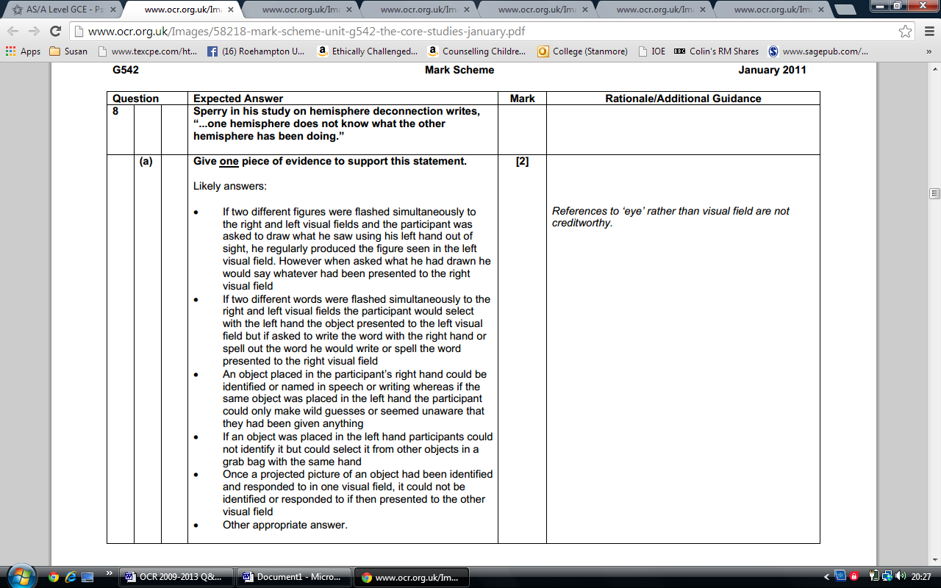

**8 (b)**

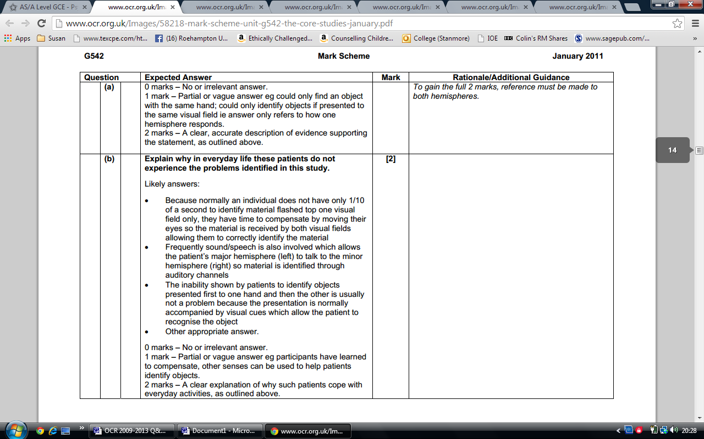

**June 2011: Question**

9. Outline **two** findings from Sperry’s study on hemisphere deconnection. [4]

**Answer**

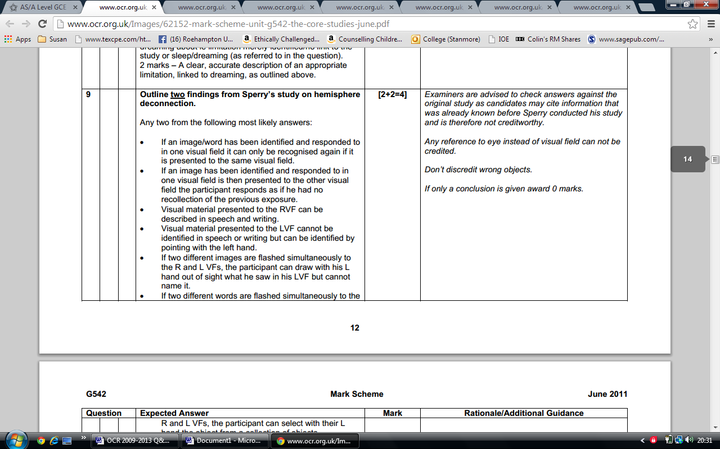

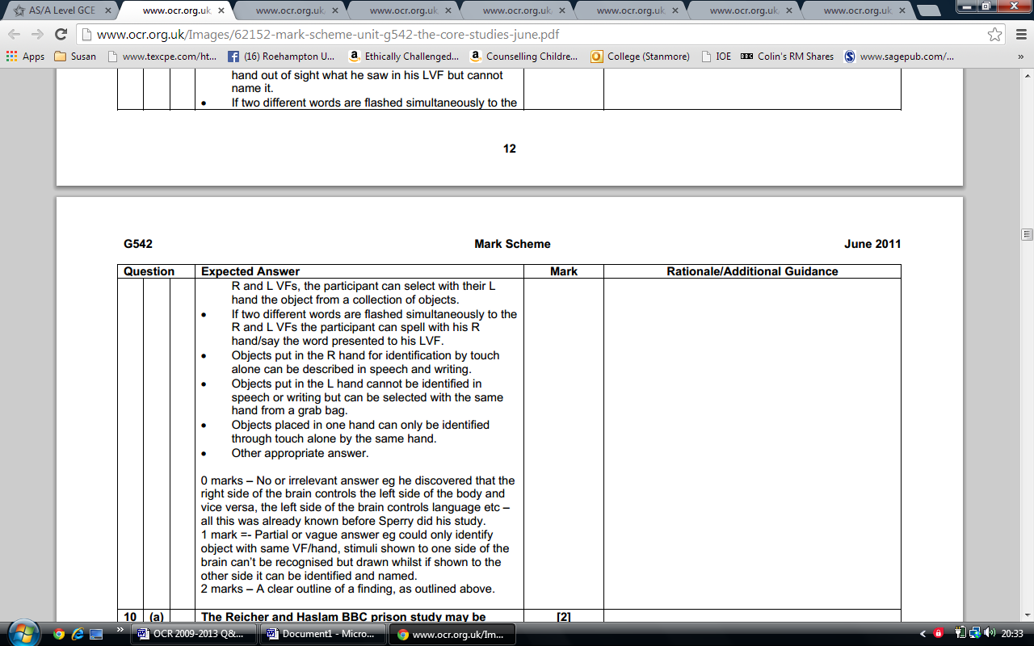

**January 2012: Question**

8. From Sperry’s ‘split brain’ study, describe how visual stimuli were presented to participants in this study. [4]

**Answer**

The participant, with one eye covered, centred his/her gaze on o designated fixation point on an upright translucent screen. The visual stimuli on 35-millimetre transparencies were arranged in a standard projector equipped with a shutter and were then back-projected at 1/10 of a second or less – too fast for eye movements to get the material into the other visual field – to either the right or left of the central fixation point

**January 2013: Question**

9. From Sperry’s ‘split brain’ study, describe **two** ways having a split brain affected the patients’ performance on the tasks in this study. [4]

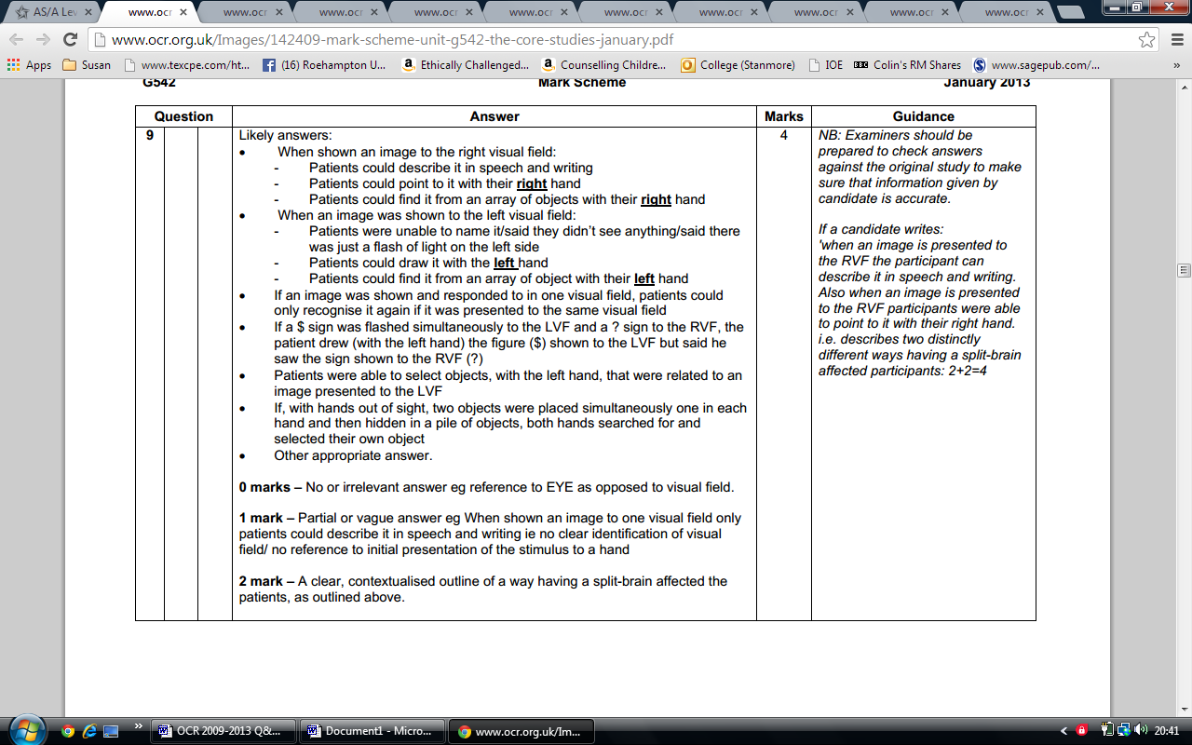

**June 2013: Question**

8. From Sperry’s ‘split brain’ study,

1. Outline how information was presented to the patient’s left visual field (LVF). [2]
2. Explain why patients could not identify in words material presented to their left visual field (LVF). [2]

Answers

a) Most likely answer:

The participant (with one eye covered), centred his gaze on (a designated fixation point in) a translucent/projection screen. Visual stimuli were then back-projected onto the screen at 1/10 of a second/flashed to the left visual field

(b)

Most likely answer:

Because material presented to the left visual field is received by the right hemisphere which is non-lingual/cannot speak or write

**June 2014: Questions**

From Sperry’s ‘split brain’ study into the psychological effects of hemisphere deconnection:

1. Describe **one** finding from the visual tests used in this study. [2]
2. Describe **one** finding from the tactile tests used in this study. [2]

**Answers**

(a)

Most likely answers:

* If an image/word has been identified and responded to in one visual field it can only be recognised again if it is presented to the same visual field.
* If an image has been identified and responded to in one visual field is then presented to the other visual field the participant responds as if he had no recollection of the previous exposure.
* Visual material presented to the LVF cannot be identified in speech and/or pointing/ drawing/ writing with the right hand and/ or but can be identified by pointing/ drawing/ writing with the left hand).
* Visual material presented to the RVF can be described in speech and/or writing/ drawing/ pointing using the right hand.
* If two different images are flashed simultaneously to the R and LVFs, the participant can select with their left hand the object from a collection of objects.
* If two different words are flashed simultaneously to the R and LVFs the participant can spell with his right hand/say the word presented to his RVF.

(b)

Most likely answers:

* Objects put in the right hand for identification by touch alone can be described in speech and writing (using the right hand).
* Objects put in the left hand cannot be identified in speech or writing but can be selected by the same hand from a scrambled pile of items / grab bag.
* Objects placed in one hand can only be identified through touch alone by the same hand.
* If two objects are placed simultaneously, one in each hand, then removed and hidden in a scrambled pile of items / grab bag, each hand will hunt for and select its own object.

Other appropriate answers should be credited

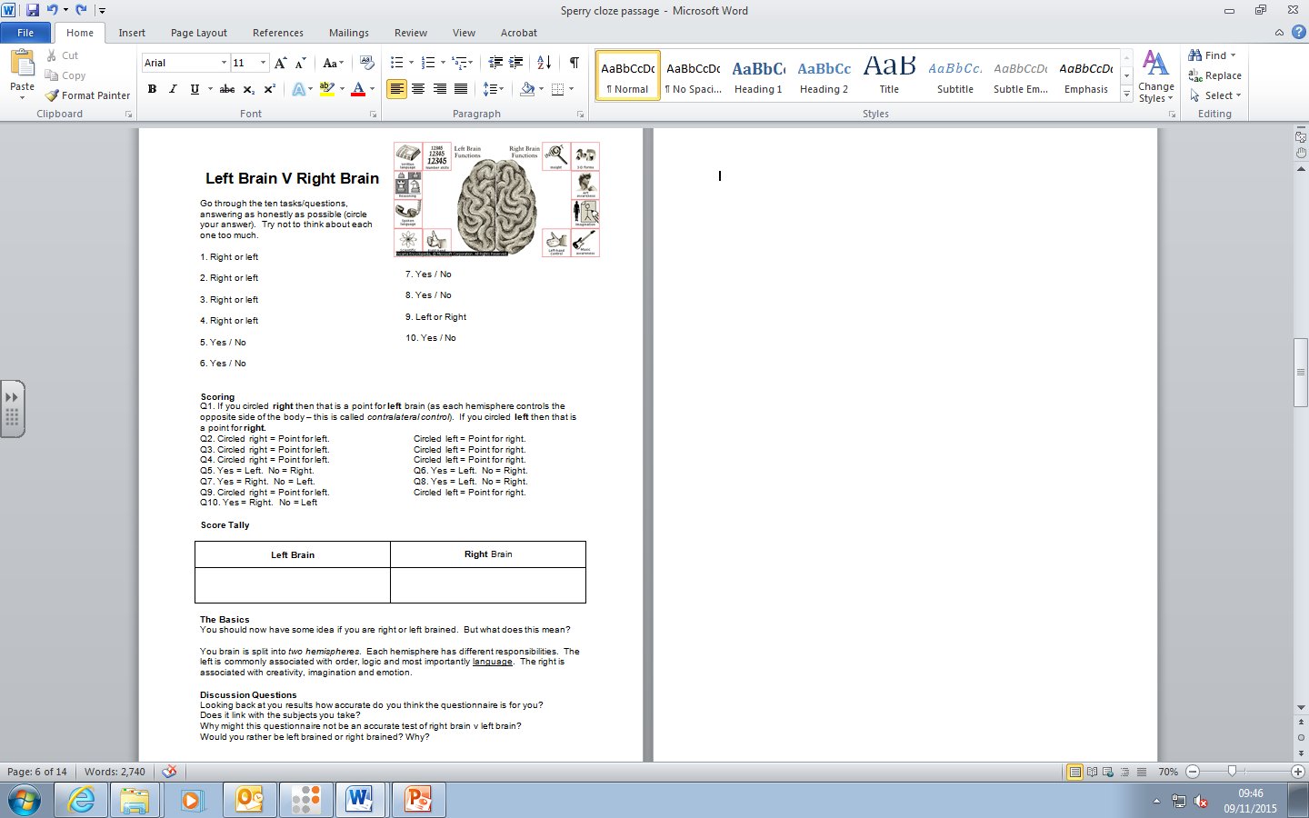

***Sperry...* Which side are you on?**

Choose the one sentence that is more true for you. Do not leave any blanks.

|  |  |  |
| --- | --- | --- |
| 1 | 1. A. It's fun to take risks. | B. I have fun without taking risks. |
| 2 | 1. A. I look for new ways to do old jobs. | B. When one way works well, I don't change it. |
| 3 | 1. A. I begin many jobs that I never finish. | B. I finish a job before starting a new one. |
| 4 | 1. A. I'm not very imaginative in my work. | B. I use my imagination in everything I do. |
| 5 | 1. A. I can analyze what is going to happen next. | B. I can sense what is going to happen next. |
| 6 | 1. A. I try to find the one best way to solve a problem. | B. I try to find different answers to problems. |
| 7 | 1. A. My thinking is like pictures going through my head. | B. My thinking is like words going through my head. |
| 8 | 1. A. I agree with new ideas before other people do. | B. I question new ideas more than other people do. |
| 9 | 1. A. Other people don't understand how I organize things. | B. Other people think I organize well. |
| 10 | A. I have good self-discipline. | B. I usually act on my feelings. |
| 11 | A. I plan time for doing my work. | B. I don't think about the time when I work. |
| 12 | A. With a hard decision, I choose what I know is right. | B. With a hard decision, I choose what I feel is right. |
| 13 | A. I do easy things first and important things later. | B. I do the important things first and the easy things later. |
| 14 | A. Sometimes in a new situation, I have too many ideas. | B. Sometimes in a new situation, I don't have any ideas. |
| 15 | A. I have to have a lot of change and variety in my life. | B. I have to have an orderly and well-planned life. |
| 16 | A. I know I'm right, because I have good reasons. | B. I know I'm right, even without good reasons. |
| 17 | A. I spread my work evenly over the time I have. | B. I prefer to do my work at the last minute. |
| 18 | A. I keep everything in a particular place. | B. Where I keep things depends on what I'm doing. |
| 19 | A. I have to make my own plans. | B. I can follow anyone's plans. |
| 20 | A. I am a very flexible and unpredictable person. | B. I am a consistent and stable person. |
| 21 | A. With a new task, I want to find my own way of doing it. | B. With a new task, I want to be told the best way to it. |

When you are finished, score yourself: ‘My score was __________ which means that I am _________________________ .’

*Derived from* The Alert Scale of Cognitive Style, *by Dr. Loren D. Crane, Western Michigan University, 1989. Reprinted with permission*.

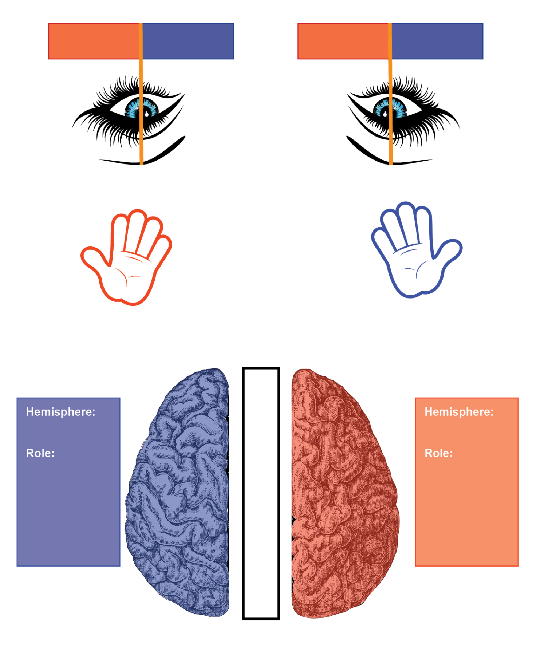Read the instructions carefully and label the drawing.

### Step 1:

Your brain is split into 2 hemispheres. Label the right and left hemispheres.

### Step 2:

Your hemispheres are connected by a bundle of fibres called the c________ c________. In the space between the hemispheres, label the c________ c­­­­_______.

### Step 2:

One of the roles of your left hemisphere is to control l________. Write down this role in the box.

### Step 3:

One of the roles of your right hemisphere is to control r________. Write down this role in the other box.

### Step 4:

Label the right and left hands.

### Step 5:

Your right hand is controlled by your left hemisphere. Draw a line connecting the right hand to the left hemisphere.

### Step 6:

Your left hand is controlled by your right hemisphere. In a different coloured pen draw a line connecting your left hand to your right hemisphere.

### Step 7:

Each of your eyes can observe both a left visual f_____ and a right visual f______. Write left visual f_____ in the red boxes.

### Step 8:

Write right visual f______ in the blue boxes.

### Step 9:

The left hemisphere controls the right visual f______. Connect the right visual f_______ (for both eyes) to the left hemisphere with the line.

### Step 10:

The right hemisphere controls the left visual f______. Connect the left visual f______ (for both eyes) to the right hemisphere.

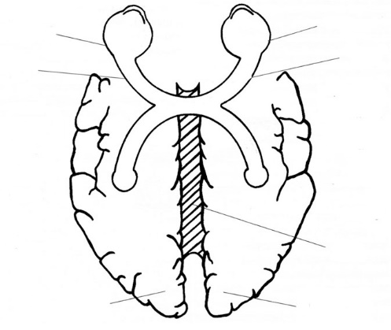Sperry: Biological

**Aim:** To investigate the effects of hemisphere disconnection and to show that each hemisphere has different functions.

**Participants:** 11 participants.

* Opportunity Sample.
* Repeated measures design
* All undergone surgery to sever their corpus callosum.

**Method:** Quasi Experiment. Qualitative Data.

* The study involves comparing the performance of the 11 participants on various tasks with people who haven't had their corpus callosum severed.
* **IV:** Whether the participants have had their hemisphere disconnected.
* 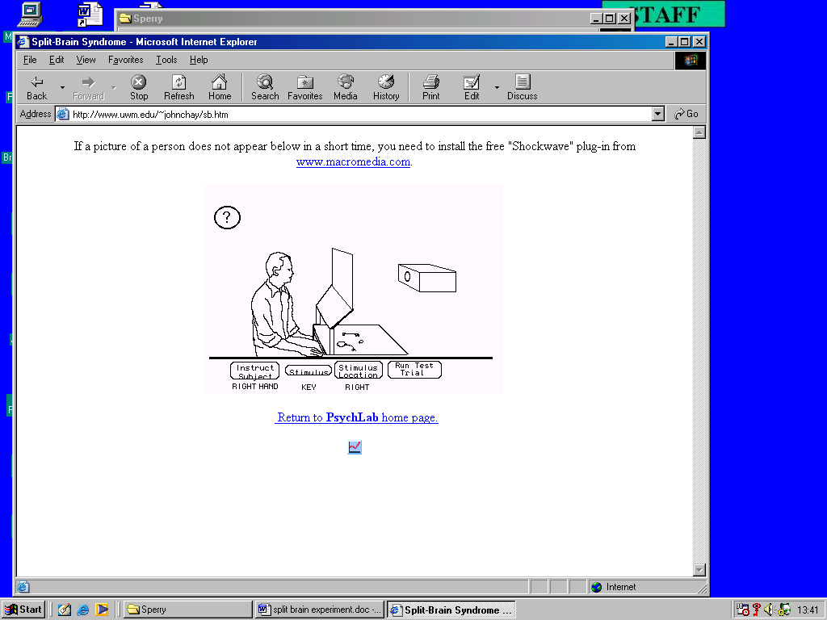**DV:** Performance of the various tasks.
* **2** **main tasks** were carried out:

**Task 1:**

* This included sending visual information to one hemisphere then asking the participant to name it.
* Participants will have a blindfold placed over one eye and then asked to use their other eye to fixate on a point in the middle of a screen.
* A visual stimulus will then be shown on the right or left side of the point for 1/10th of a second.
* As language is processed in the left hemisphere, when a stimulus is presented to the left visual field the 'split-brain' participants should not be able to name it.

**Task 2:**

* This included sending tactile information to one hemisphere then asking the participants to name it.
* Participants will have a stimulus placed in one of their hands while still unable to see and then asked to name it.
* As this is dealt with by the left hemisphere, when a stimulus is presented to their left hand the 'split-brain' participants should not be able to name it.

**Results:**

**Task 1:**

* When a stimulus was presented to one visual field and then the other, they responded as if they had only seen it once.
* If a stimulus was presented to the right visual field for a second time, they responded as if they had seen it before.
* They were not able to give a description of the stimulus if presented to the left visual field as it went unnoticed or appeared as a flash however right-handed participants were able to non-verbally select a matching stimulus with their left hand.
* This was the opposite if the stimulus was presented to the right visual field.
* If two symbols were presented at the same time and the participants were asked to draw they had saw with their left hand, they would draw what they saw on their left visual field.
* However if they were asked what they had drawn, they would name the stimulus presented to their right visual field.

**Task 2:**

* Objects put in the participants right hand for identification could be described both verbally or written down, but in their left hand they either guessed or didn't know anything was there.
* If an object was taken from the left hand and placed in a grab bag, they could recognise and retrieve the object with the same hand.
* If two objects were placed in both hands then placed in two separate grab bags, the participants were able to find the item that that hand was holding both individually and the same time.

**Evaluation:**

|  |  |
| --- | --- |
| **Strengths** | **Weaknesses** |
| As it is looks at their brain, they are unable to show **Demand Characteristics** as it's beyond their control. | **Sample:** A very small sample was used so the results can't be generalised to all split-brain people. |
| Due to it being a **Quasi Experiment,** it is more ecologically valid as the IV is naturally occurring so the results are more likely to be true as they come naturally. | It would be more **valid** to compare the split-brain ppts with people who have severe epilepsy like they did, as this was the reason for why they had their CC cut. |
| Lots of **Qualitative Data** is collected which gives lots of detail on specifically what they are able to do and what not due to being 'split-brain', making the results rich in detail. | Due to using a **Quasi Experiment**, there is not much control over the EVs as the IV is naturally occurring (i.e. they may not be able to view a symbol due to partial blindness in a one eye). |

Sperry: Biological

**Aim:** To the effects of hemisphere disconnection and to show that each hemisphere has different functions.

**Participants:** 11 participants.

* Opportunity .
* Repeated design
* All undergone to sever their callosum.

**Method:** Quasi Experiment. Qualitative Data.

* The study involves the performance of the 11 participants on various tasks with people who haven't had their corpus callosum severed.
* **IV:** Whether the have had their hemisphere disconnected.
* **DV:** of the various tasks.
* **2** **main tasks** were carried out:

**Task 1:**

* This included sending information to one hemisphere then asking the participant to name it.
* Participants will have a placed over one eye and then asked to use their other eye to fixate on a point in the middle of a screen.
* A visual will then be shown on the or left side of the point for 1/10th of a second.
* As language is in the left hemisphere, when a stimulus is presented to the left visual field the 'split-brain' participants should not be able to name it.

**Task 2:**

* This included tactile information to one hemisphere then asking the participants to name it.
* Participants will have a stimulus placed in one of their while still unable to see and then asked to name it.
* As this is dealt with by the left , when a stimulus is presented to their left hand the 'split-brain' participants should not be able to name it.

Blindfold

Comparing

Corpus

Hands

Hemisphere

Investigate

Measures

Participants

Performance

Processed

Right

Sample

Sending

Stimulus

Surgery

Visual

**Results:**

**Task 1:**

* When a was presented to one visual field and then the other, they responded as if they had only seen it once.
* If a stimulus was to the right visual field for a second time, they responded as if they had seen it before.
* They were not able to give a of the stimulus if presented to the left visual field as it went or appeared as a flash however right-handed participants were able to non-verbally select a matching stimulus with their left hand.
* This was the opposite if the stimulus was presented to the right field.
* If two symbols were presented at the same time and the participants were asked to draw they had saw with their left hand, they would what they saw on their left visual field.
* However if they were asked what they had drawn, they would name the stimulus presented to their right visual field.

**Task 2:**

* Objects put in the participants right hand for could be described both verbally or written down, but in their left hand they either guessed or didn't know anything was there.
* If an object was taken from the left hand and placed in a grab bag, they could recognise and retrieve the with the same hand.
* If two objects were placed in both hands then placed in two separate grab bags, the participants were able to find the that that hand was holding both individually and the same time.

**Evaluation:**

|  |  |
| --- | --- |
| **Strengths** | **Weaknesses** |
| As it is looks at their brain, they are unable to show **Characteristics** as it's beyond their control. | **Sample:** A Very small sample was used so the results can't be to all split-brain people. |
| Due to it being a **Quasi Exp,** it is more ecologically valid as the IV is ___ occurring so the results are more likely to be true as they come naturally. | It would be more **valid** to compare the split-brain ppts with people who have severe like they did, as this was the reason for why they had their CC cut. |
| Lots of **Qualitative Data** is collected which gives lots of on specifically what they are able to do and what not due to being 'split-brain', making the results rich in detail. | Due to using a **Quasi Experiment**, there is not much control over the EVs as the IV is naturally occurring (i.e. they may not be able to view a due to partial blindness in a one eye). |

**Demand**

Description

Detail

Draw

Epilepsy

Generalised

Identification

Item

Naturally

Object

Presented

Stimulus

Symbol

Unnoticed

Visual

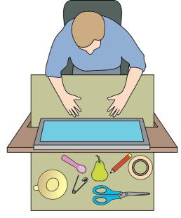**Sperry (1968): Results of the tactile and visual tasks**

Fill in the gaps in the boxes below:

|  |  |
| --- | --- |
| The left hemisphere controls:  1 Language  2 The _____________ hand  3 The right visual field | The right hemisphere controls:  1 Drawing (NOT language)  2 The left hand  3 The __________ visual field |

**Tactile task results**

|  |  |
| --- | --- |
| **Without looking, participants picked up an object with their right hand.** | |
| Hemisphere used: |  |
| **Participants were then asked to say out loud what they were holding.** | |
| Could participants do this? |  |
| Why/Why not? |  |

|  |  |
| --- | --- |
| **Without looking, participants picked up an object with their left hand.** | |
| Hemisphere used: |  |
| **Participants were then asked to say out loud what they were holding.** | |
| Could participants do this? |  |
| Why/Why not? |  |

1

**Visual task results**

 ?

|  |  |
| --- | --- |
| **Participants were flashed a stimulus to one of their visual fields.** | |
| Which visual field was the ‘?’ stimulus presented to? |  |
| Which hemisphere would have seen the stimulus? |  |
| **Participants were then asked to identify what they saw.** | |
| Would participants have been able to do this? |  |
| Why/Why not? |  |
| If not, what could they do? |  |

$ 

|  |  |
| --- | --- |
| **Participants were flashed a stimulus to one of their visual fields.** | |
| Which visual field was the ‘$’ stimulus presented to? |  |
| Which hemisphere would have seen the stimulus? |  |
| **Participants were then asked to identify what they saw.** | |
| Would participants have been able to do this? |  |
| Why/Why not? |  |
| If not, what could they do? |  |

2

Key  Case

|  |  |
| --- | --- |
| **Both words were flashed up on either sides of the dot and were seen by both visual fields.** | |
| **KEY** | **CASE** |
| Which visual field was each word presented to? | |
|  |  |
| Which hemisphere was each word presented to? | |
|  |  |
| Would the participant have been able to identify this stimulus verbally? | |
|  |  |
| If not, what could the participant do? | |
|  |  |

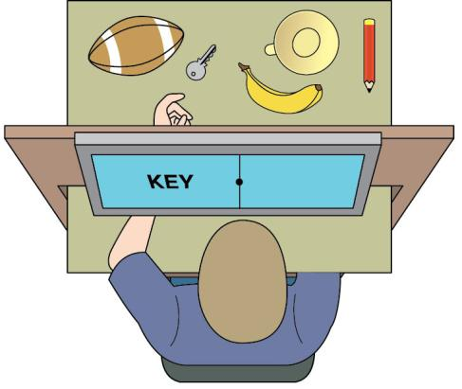

3

Results page 1: Tactile task results

Without looking, participants picked up an object with their right hand.

Hemisphere used: LEFT

Participants were then asked to say out loud what they were holding.

Could participants do this? YES

Why/Why not? LH is in control of language

Without looking, participants picked up an object with their left hand.

Hemisphere used: RIGHT

Participants were then asked to say out loud what they were holding.

Could participants do this? NO

Why/Why not? RH is mute

Results page 2: Visual task results

Participants were flashed a stimulus to one of their visual fields.

Which visual field was the ‘?’ stimulus presented to? RVF

Which hemisphere would have seen the stimulus? LH

Participants were then asked to identify what they saw.

Would participants have been able to do this? YES

Why/Why not? LH is in control of language

If not, what could they do? They could do this.

Results page 3: Visual task results

Participants were flashed a stimulus to one of their visual fields.Which visual field was the ‘$’ stimulus presented to? LVF

Which hemisphere would have seen the stimulus? RH

Participants were then asked to identify what they saw. Would participants have been able to do this? NO

Why/Why not? RH is mute.

If not, what could they do? DRAW it with their left hand

Results page 4: Composite Words

Both words were flashed up on either sides of the dot and were seen by both visual fields.

KEY CASE

Which visual field was each word presented to?

KEY = LVF

CASE = RVF

Which hemisphere was each word presented to?

KEY = RH

CASE = LH

Would the participant have been able to identify this stimulus verbally?

KEY = NO

CASE = YES

If not, what could the participant do?

KEY = NO, but could DRAW it with their left hand

CASE = YES can identify it verbally

Sperry: Research Method

|  |  |  |  |  |  |  |  |  |  |  |  |  |  |  |  |  |  |  |  |
| --- | --- | --- | --- | --- | --- | --- | --- | --- | --- | --- | --- | --- | --- | --- | --- | --- | --- | --- | --- |
| G | E | E | S | E | N | E | P | S | T | S | E | T | T | N | N | L | A | S | I |
| E | L | S | A | N | E | D | E | A | D | G | A | I | T | S | M | S | P | T | E |
| I | I | I | Y | S | O | O | R | E | N | A | W | O | R | I | D | E | I | E | S |
| F | T | N | O | O | E | I | F | P | E | L | W | N | E | A | O | C | D | E | N |
| S | C | O | P | N | E | N | O | G | R | E | D | N | U | L | O | T | X | D | C |
| R | A | E | H | P | S | N | R | I | D | I | E | S | A | C | V | P | O | D | D |
| E | T | A | T | N | S | D | M | N | C | R | E | S | I | E | E | E | S | E | D |
| H | H | M | C | O | P | H | W | D | S | E | P | N | S | R | T | T | C | A | S |
| C | T | H | U | E | R | S | M | E | S | E | E | E | I | E | S | O | I | E | G |
| R | D | D | E | T | A | L | U | P | I | N | A | M | U | I | N | N | S | M | E |
| A | Y | D | O | E | F | N | P | E | Y | I | E | A | A | N | W | O | A | A | S |
| E | D | S | T | T | E | I | N | N | C | N | N | T | E | T | N | E | U | T | T |
| S | I | E | P | O | I | T | A | D | T | S | S | C | N | T | O | E | Q | P | Y |
| E | O | D | P | E | U | S | T | E | L | N | T | T | R | D | L | O | A | T | R |
| R | T | H | I | E | L | U | W | N | C | I | O | R | Y | E | R | O | N | A | C |
| S | E | E | I | N | N | I | N | T | O | A | U | N | R | E | S | T | R | T | S |
| E | H | W | U | C | I | D | P | N | C | F | R | E | C | T | S | E | I | S | L |
| T | A | E | I | I | Z | I | E | E | I | U | A | R | S | S | L | G | P | N | O |
| E | N | I | U | I | N | R | W | N | T | L | C | R | E | E | E | E | O | C | T |
| P | E | I | R | S | A | D | I | H | T | P | N | M | I | M | A | E | A | E | N |

**CLOZE Passage**Sperry's study is a _________/natural ___________________ because the _____________________ variable – having a split brain or not – was not directly _____________________ by the _____________________. Ps with split-brains had already _________________ hemisphere _______________________ to reduce severe _______________. The _________________ variable was the Ps ability to _____________ a variety of visual and _____________ tests. Some say it is a collection of _______ studies, because so many _________ were made on just 11 Ps.

Timed Test Name _________________

1. What method is Sperry's research?

1. Correlation
2. Lab experiment
3. "Natural experiment"
4. "Observation

2. What is the name of the bundle of fibres that connects the left and right hemispheres?

1. Corpus Christi"
2. "Corpus Callosum
3. Corpus Colosseum"
4. "Corpus Commisure"

3. How many participants did Sperry use?

1. 11
2. 13
3. 15
4. 12

4. What is the correct name for the operation which disconnects the 2 hemispheres?

1. Labotomy
2. Callosumotomy
3. Vasectomy
4. Commisurotomy

5. What medical condition had Sperry's participants suffered?

1. Asthma
2. Epilepsy
3. Alzheimer's
4. Panic attacks

6. What is the name of the equipment used by Sperry?

1. Gyroscope
2. Periscope
3. Laptop projector
4. Tachistoscope

7. Images were flashed on screen for how long?

1. 0.01 seconds
2. 0.1 seconds
3. 1 second
4. 10 seconds

8. What did participants wear during the tests?

1. Eye patch
2. Scarf
3. Gloves

10. In the $ (LVF) and ? (RVF) Test what did the participant draw with their left hand?

1. ?
2. $

11. In the $ (LVF) and ? (RVF) Test what did the participant say they saw?

1. ?
2. $

12. Which of these is a composite word that could have appeared in the composite test?

1. Spoon
2. Hammer
3. Keycase
4. Flo Rida

13. If "keycase" is flashed on the screen what will participants say they saw?

1. Key
2. Case

14. If "keycase" is flashed on the screen what will participants find with their left hand?

1. Key
2. Case

15. If "keycase" is flashed on the screen what will participants find with their right hand?

1. Key
2. Case

16. In the tactile test how could Ps identify an object placed in their right hand?

1. Speech
2. Writing
3. With left hand
4. With right hand

17. In the tactile test how could Ps identify an object placed in their left hand?

1. Speech
2. Writing
3. With left hand
4. With right hand

18. In the tactile test what would Ps say if an object was placed in their left hand?

1. I'm not holding anything
2. The correct answer
3. That hand is numb
4. I don't get messages from that hand

19. In the tactile test how would Ps explain correctly naming an object placed in their left hand?

1. I was just guessing
2. I can tell what it is from touching it
3. I must have done it unconsciously

20. In the dual processing task what happens?

1. Images are flashed to both visual fields
2. Objects are placed in both hands

21. What are the results of the dual processing task?

1. The left hand will find the object put in the right hand
2. The left hand will ignore the object put in the right hand
3. The right hand will find the object put in the left hand
4. The right hand will ignore the object put in the right hand

22. Which of these are problems that can be experienced by a split brain patient?

1. Slower reactions to dual tasks
2. Long term memory problems
3. Limited attention span
4. Short term memory problems

23. Sperry's research showed which hemisphere was dominant for spatial awareness?

1. Right
2. Left

24. If a nude pin up picture is shown to the LVF which of the will the participant do?

1. Blush
2. Giggle
3. Say I just saw a nude

25. Which of these is not a left hemisphere function?

1. Speech
2. Language
3. Emotion
4. Calculation

26. Which of these is not a right hemisphere function?

Intuition

1. Logic
2. Emotion
3. Spatial construction

27. Which research design was used in Sperry's experiment?

1. Independent
2. Repeated measures
3. Matched pairs

28. How do the two hemispheres work in split brain patients compared to normal brains?

1. independently
2. together

29. The sample lacked representativeness, which means it

1. Cannot be applied to everyone
2. Can be applied to everyone

30. If an image/word has been shown in one visual field it can only be recognised again if

1. it is presented to the same visual field
2. it is presented to the opposite field
3. it is presented to them in touch

31. Describe what is meant by the term ‘hemisphere deconnection’? [2]

32. Explain why a ‘split brain’ patient could not describe in speech material presented to their left visual field. [2]

Answers

1. C
2. B
3. A
4. D
5. B
6. D
7. B
8. A
9. -
10. B
11. A
12. C
13. B
14. A
15. B
16. A or B or D
17. C
18. A or B or D
19. A or C
20. B
21. B
22. C
23. A
24. A or B
25. C
26. B
27. B
28. A
29. A
30. A

**Sperry (1968) Hemisphere deconnection and unity in consciousness**

**Thinking like a Psychologist - Evaluating the Core Study**

**What are the strengths and weaknesses of the method used by Sperry?**

Sperry conducted a quasi-experimental design. One weakness of this type of design is that it does not give the researcher full control over the independent variable (whether someone had their corpus callosum severed). However, quasi-experimental designs allow researchers to investigate variables that are not able to be investigated in strict laboratory experiments. Sperry’s research can be seen as similar to a collection of detailed case studies conducted with highly controlled and objective laboratory equipment and procedures. The major strength of Sperry’s work is definitely the techniques that he developed which allowed the functions of the two hemispheres to be studied in ways which had previously been impossible.

**Was the sample representative?**

Sperry had eleven participants who had already undergone surgery to severe their corpus callosum. Eleven would be considered quite a small number in other types of studies but it would not have been possible to find large numbers of people who had had this operation. There are two questions that need to be considered. Firstly, are these eleven people representative of everyone who has had this operation, and secondly, can the results of this study be used to tell us anything about the functioning of the ‘normal’ brain? The results suggest that all the eleven participants experienced very similar effects to each other and so it would be safe to conclude that anyone who had this operation would experience these effects. However, as Sperry did not control the independent variable in this study, he was not able to test these participants prior to the operation. It is possible that their brain functioning may have been atypical (different from the norm) before the operation and this would make drawing conclusions about the functions of the hemispheres in non separated brains more difficult.

**What type of data was collected in this study?**

There are examples of both quantitative and qualitative data in this study. The majority of the data is quantitative as Sperry simply records whether something could be identified or not. This is the important data in this study as it is from this that Sperry that is able to draw his conclusions about the different functioning of the two hemispheres. However, the results are illustrated with some revealing qualitative examples of the experiences of the split-brain patients and this adds significantly to our attempt to understand the experiences of these people. For example, the description of patients giggling at nude photographs presented to their right hemisphere whilst denying that they have seen anything is far more revealing that simply reporting how many responded and under what conditions.

**Was the research ecologically valid? / Can the results be applied to real life?**

In a sense this research has very little ecological validity as the techniques that Sperry developed artificially separate the visual and tactile information received by the individual. It is difficult to think of a situation where this would happen in real life, and as we saw in the Core Study, split brain patients have a number of simple strategies for coping in the real world that they were unable to use in the laboratory conditions. On the other hand, ecologically valid research should be studying real problems and Sperry’s research is looking at a naturally occurring variable (split brain as a result of the operation) and trying to understand exactly what effects this operation has on the individuals concerned.

**Was the research useful?**

The research was extremely useful. Sperry’s work revealed facts about the lateralisation of functions between the two hemispheres that had only been suggested by previous studies. There are many ways in which this knowledge could be applied to helping people cope with the effects of brain damage.

Choose one question from Q1-3

1. Explain one reason why Sperry’s research IS and one reason why Sperry’s research IS NOT useful. [6]
2. Explain one reason why Sperry’s research IS and one reason why Sperry’s research IS NOT valid. [6]
3. Explain one reason why Sperry’s research IS and one reason why Sperry’s research IS NOT ethical. [6]

Choose one question from Q4-5

1. Explain one strength and one weakness of Sperry’s sample. [6]
2. Explain one strength and one weakness of the type of data collected in Sperry’s study. [6]

Choose one question from Q6-8

1. Explain one advantage and one disadvantage of taking the nature side of the nature / nurture debate with reference to Sperry’s study on regions of the brain. [6]
2. Explain one advantage and one disadvantage of taking the determinism side of the free will / determinism debate with reference to Sperry’s study on regions of the brain. [6]
3. Explain one reason why Sperry’s research shows that Psychology IS a science and one reason why Sperry’s research shows that Psychology IS NOT a science. [6]