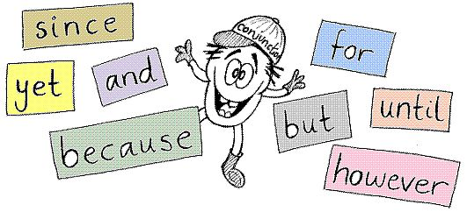
Useful Phrases for Psychology Essays

Conjunctions
Scatter these at the beginning of sentences / paragraphs and to link points of your argument together

Therefore
However
As a result
For example
As you can see
In relation to
This appears to
In order to
While
It is clear that
Although
Additionally
Furthermore
Whereas
Also
As well as
Such as
As such
An example of this

Implications
Use these to fully explain your evaluative points!

This demonstrates that
This is good/bad because
This suggests that
This states that
This shows that
This challenges
This means that
This conveys
This provides support for
It can be concluded that
This is good/bad because
This conveys
Resulting in
This supports
This provides reinforcement for
This raises the possibility of
This shows support for
This contradicts
This agrees/does not agree with

Comparative Phrases
Use these for comparing different therapies, explanations, theories, results of studies, approaches, etc.

Similarly
This challenges
In contrast
When compared to
This reflects
Equally
On the other hand
In comparison
Contrary to this
To compare
Whereas
Others would argue
This is better/worse because
This is weaker/stronger because

