Psychology prep 30 marks

* Point
* Explanation
* Example from the study to show this.
* Conclusion – why does this matter?

**January 2010**

The study by Loftus and Palmer on eye witness testimony involved the experimental method. Describe one strength and one weakness of the experimental method used in this study. [4]

**January 2009**

1. Identify the independent variable in the first experiment conducted by Loftus and Palmer on eye witness testimony. [2]
2. Outline how the independent variable was manipulated in this experiment. [2]

**June 2009**

From the study by Loftus and Palmer on eye witness testimony, outline two ways in which the procedure was standardised. [4]

**June 2010**

The study by Loftus and Palmer on eye witness testimony used two laboratory experiments.

1. Identify the two experimental groups in Experiment 2. [2]
2. Outline one difference between the responses given by the two experimental groups in Experiment 2. [2]

**June 2012**

From the study by Loftus and Palmer on eye witness testimony, describe the sample in the first experiment. [2]

**January 2011**

Describe the procedure in the second experiment conducted by Loftus and Palmer on eye witness testimony. [4]

If the question says ‘in this study’, you need to use words unique to the study to show AO2 context

**January 2012**

From the study by Loftus and Palmer on eye witness testimony, outline two findings from the second experiment. [4]

**June 2014**

In their study on eye witness testimony, Loftus and Palmer proposed that two kinds of information form one’s memory of an event.

Describe these two kinds of information in relation to this study. [4]

Memory is the retention and use of prior learning

Schemas = a mental concept that informs a person about what to expect from a variety of experiences and situations. Schemas are developed based on information provided by life experiences and are then stored in memory

What characteristics do you associate with the following?

Summarise in less than 30 words how mental schemas impact memory recall

Mental schemas can help or impair memory recall. The information is easily recalled because we use stereotypes and expectations to help us. This is an unconscious process that can make memory better or inaccurate

The Multi-Store Model of Memory

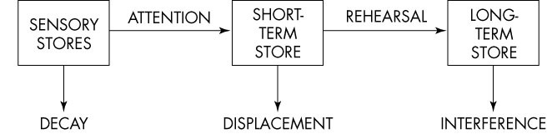

Give an example of something you can do to pay attention

Write ONE strategy YOU will use to revise well throughout your A Level course

Processing: Eye Witness Testimony Clips

Summarise in less than 30 words how leading questions impact memory recall

When you are asked a leading question, you may answer inaccurately as leading questions imply a certain answer. Therefore your memory is not accurate

Reconstruction of Automobile Destruction.

*Journal of Verbal Learning and Verbal Behaviour, 13, 585–589.*

Loftus, E. F. & Palmer, J. C. (1974)

**Aim**: to investigate the effect of leading questions on eyewitness accounts and also the effect that leading questions might have on later memory for what happened.

**Hypothesis**: That the strength of the verb used in the leading question (contacted, hit, bumped, collided, smashed) will have a significant effect on participant reports of the speed of the crash (mph).

**Experiment 1**

Method: A laboratory experiment. Procedure: 45 student participants watched a video of a car accident (the video was part of a driver safety film).

Afterwards the participants were asked to write an account of what they had seen, and then given a questionnaire which included *the critical leading question*.

The participants were divided into 5 groups and each group received a slightly different version of the critical question, either containing the verb *‘smashed’, ‘collided’, ‘bumped’, ‘hit’* or ‘*contacted*’.

**Findings**: the leading question did affect participants’ perception of speed.

**Experiment 2**

The first experiment found that leading questions do affect eyewitness reports, but do they also affect the way the information is stored in memory and later retrieved?

In another laboratory experiment, 150 student participants, in three groups of 50, were shown a film of car accident and were given a questionnaire. Group 1 were asked the leading question containing the word ‘hit’, group 2 were asked it with the word ‘smashed’ and group 3 (the control group) were not asked a leading question. A week later the participants returned and were asked some further questions, including the critical question ‘*Did you see any broken glass?*’ (there had been no broken glass in the film).



**Findings**: Those participants who thought the car was travelling faster (the ‘smashed’ group) were more likely than the others to produce a false memory of seeing broken glass. This suggests that their memory of what they had seen was changed by the way they had been questioned.

**Conclusion**: the meaning of the verb used in the leading question (the semantics of the question) had become integrated with the memory of the event, thus changing the memory and causing a false memory to be constructed. What happens after we have witnessed an event can alter our memory of the event.

Evaluating the Core Study

**What are the strengths and weaknesses of the method used in this study?**

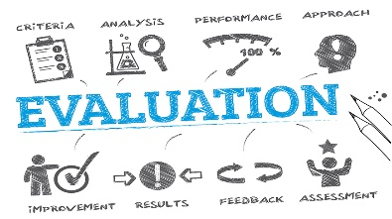The method used in this study was laboratory experiments. L&P manipulated the words used in the questions and measured the effect of this on recall. They did this in controlled conditions, keeping as many other variables as possible the same, thus allowing them to conclude that it was the words used in the questions that caused the differences in recall. The more variables you have control over, the easier it becomes to draw conclusions about the effect of the IV on the DV.

However, the high level of control usually means that you have created an artificial situation which make it difficult to apply your results to everyday life (low ecological validity). Ps know that they are taking part in a lab experiment, so they look for clues as to how to behave (demand characteristics) and usually want to help the experimenters by giving them the results that they think they want.

**What type of data was collected in this Study?**

L&P collected quantitative data (speed estimates and numbers of people saying that they had seen a broken headlight). Quantitative data is very useful for making comparisons and it allows statistical analysis to be conducted but it is fairly superficial and does not tell us anything about why people gave the answers that they did.

**How ecologically valid was this research?**

There are many differences between observing an event like a car crash in real life and observing one on a TV screen as part of an experiment. Some of these differences are:

* In an experiment, you are expecting something to happen and may be paying more attention to what is going on.
* The event is likely to be far less distressing on film than it would be in real life. This may affect our memory for the event.
* In an experiment, you may well expect to be asked questions about what you are watching and this may make you attend to the film in a different way.
* In real life, there may be consequences arising from the answers that you give and this may put pressure on the witness.

As this laboratory experiment had low ecological validity, it may not tell us very much about how people’s memories are effected by leading questions in real life.

**How representative were the sample of participants?**

L&P used student Ps in both of the studies. It may be that students are not representative of the general population and therefore it may be difficult to generalise from the results of this study to people in general, because:

* Students are usually young; it is possible that memory is better when you are young.
* Students are used to taking in lots of information and then being asked questions about it. People who have not studied for many years may be less used to this.
* Students may be less experienced drivers and less confident in their ability to estimate speed. This may have led them to be more swayed by the words in the questions.
* Students may be more susceptible to demand characteristics especially if they are students of the researchers conducting the research.

**How useful was this research?**

The conclusion that leading questions can affect memory has important implications for interviewing witnesses, both by police and by lawyers in court some time later. Interviewers should avoid leading questions and should be careful to word questions in ways that do not suggest an answer to the person that they are interviewing.



Strengths

Limitations

Place the letters A – M in the correct notepad above.

1. Accidents witnessed shown randomly - to avoid order effects
2. Can establish cause and effect
3. Critics have criticised Loftus’ explanation and said that it is not just the type of question but that other factors may influence your memory of an event e.g. alcohol, food, emotions, meaning.
4. Critics have criticised Loftus’ explanation and said that post event information does not change the witness’s original memory forever, they suggest that the witnesses merely follow the interviewers suggestion. The original memory can be retrieved under the right conditions.
5. High reliability
6. Lacked ecological validity (real life situation would be more emotionally arousing, participants expecting to watch, more detail e.g. context in real crash but second experiment better 4 second crash in a 1 minute video)
7. Not representative sample (students)
8. Participants have had an expectation that they had to remember something.
9. The research has been really helpful in real life. Based on evidence like this, the Devlin report (1976) recommended that a jury could not convict on eye witness testimony alone in the UK.
10. The research has been really helpful in real life. The reconstructive hypothesis has led to police and lawyers using less leading questions.
11. Useful as the research has practical implications to police and law
12. Variables fairly operationalised
13. Well controlled (used control group who were not asked about speed)

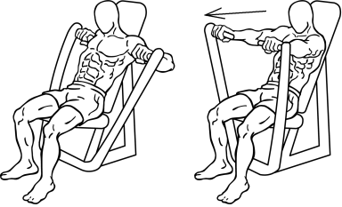

Flex you P.E.C.s (Point – Explanation – Conclusion

____ is strength / limitation of Loftus’ study because _______ __________________________________________________ __________________________________________________ __________________________________________________ _________________________________________________________

How Useful is it?

One of the reasons psychological research is conducted is to help us with practical situations in the real world.

How useful do you think the Loftus and Palmer study is? Explain how the results and conclusions could be applied in the following situations.

|  |
| --- |
| When police question a witness immediately after a crime has been committed. |
| When lawyers are trying to find a suspect guilty during a court case. |
| When a psychoanalyst is questioning a patient about their childhood traumas. |
| When a doctor in A&E is trying to find out the cause of an individual’s injury. |

****Research Methods Focus: Design your own study

On paper 1 section B, you will be asked to design your own study on a topic area.

There are 4 types of question you could be asked:

* **Experiment** (like your own experiment on Kim’s Game)
* **Observations** (you did an observation on X factor bad auditions and how your friends present themselves on Facebook)
* **Correlations** (you looked at the number of hours slept and dreams)
* **Self-reports** (you chose to write questionnaire either pets & stress, gender & car colour, weather & mood)



The question is worth 15 marks. For Level 3 (up to Grade B), you will need to repeat the following structure for each of the 4 choices given to you:

* Feature (from each of the bullet points)
* Explained (how you would be doing this – enough for replication)
* in Context (using the unique words of the story)
* Justified (why it is right to do here)
* referring to Own research (to show a similarity).



For Level 4 (up to grade A*), you will also need to give as much detail as possible into the procedure for someone else to be able to **replicate** your ideas.

Design an experiment to show that people who ***process*** the material in their short-term memory are more likely to remember it for longer.

**Justify** your decisions as part of your explanation. You must refer to:

* Laboratory or Field Experiment
* Volunteer or Snowball sampling
* Independent measures or Matched pairs experimental design
* The inferential statistical test you will use.

You should use your own experience of carrying out an experiment to inform your response. [15]

Paper 2 Section C: Practical applications

In a simple experiment conducted by psychology students, a year 9 pupil is instructed to approach a number of teachers.

They are told to engage the teacher in conversation for either 15 or 30 seconds. Thirty seconds after the conversation ends, the psychology student asks the teacher to recall details of the year 9 pupil they’ve just been speaking to using a five item checklist.

The checklist contains items relating to the year 9 pupils appearance such as hair colour, tie done up or shirt tucked in etc. The results of the study showed that in the longer 30 second condition, teachers were significantly more accurate in their recall.

Identify one psychological issue raised by the above source. Support your answer with evidence from the source. [3]

Explain how the above source is relevant to the cognitive area of psychology. Support your answer with evidence from the source. [4]

Outline one piece of psychological research that links to the above source and justify how it relates to the above source. [6]

**January 2010**

The study by Loftus and Palmer on eye witness testimony involved the experimental method. Describe one strength and one weakness of the experimental method used in this study. [4]

**Answers**

Strength (most likely answer)

* It gives the researcher a high level of control over variables eg here all participants saw exactly the same film clips.

Weakness (most likely answer)

* It is low in ecological validity e.g. here in real life, eyewitness testimony is not based on watching film clips and then completing questionnaires.

**January 2009**

1. Identify the independent variable in the first experiment conducted by Loftus and Palmer on eye witness testimony. [2]
2. Outline how the independent variable was manipulated in this experiment. [2]

**Answers**

1. The verb used in the critical question (smashed / collided / hit / bumped / contacted.)
2. Each participant had to answer a question estimating how fast the cars were going when the accident happened. The question was, ‘About how fast were the cars going when they ----- each other? The verb was one of smashed / collided / hit / bumped / contacted.

**June 2009**

From the study by Loftus and Palmer on eye witness testimony, outline two ways in which the procedure was standardised. [4]

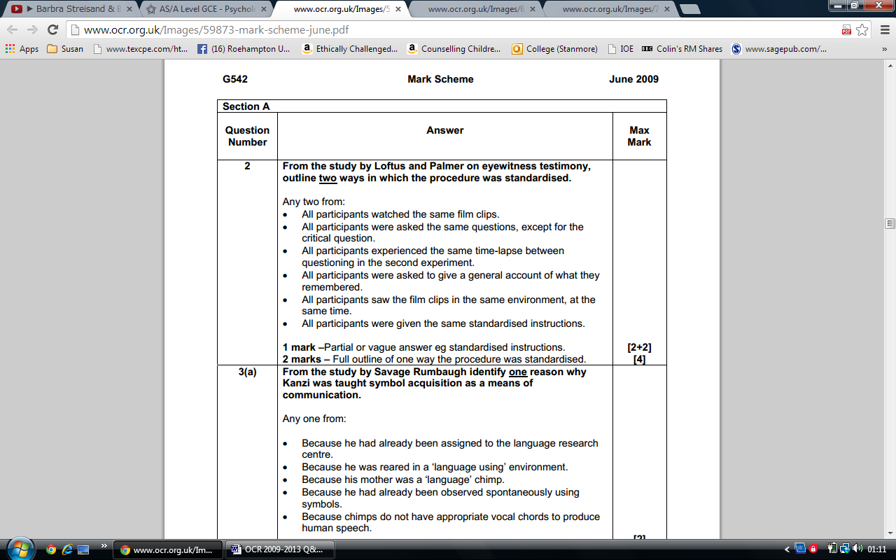

**June 2010**

The study by Loftus and Palmer on eye witness testimony used two laboratory experiments.

1. Identify the two experimental groups in Experiment 2. [2]
2. Outline one difference between the responses given by the two experimental groups in Experiment 2. [2]

**Answers**

1. The group which had the verb ‘smashed’ in the critical question. The group which had the verb ‘hit’ in the critical question.
2. Any one from:

* More participants with the verb ‘smashed’ in the critical question reported seeing broken glass than those in either the ‘hit’ or control groups/other groups
* The mean estimate for speed was higher for the ‘smashed’ group than the ‘hit’ group.

**June 2012**

From the study by Loftus and Palmer on eye witness testimony:

1. Describe the sample in the first experiment. [2]
2. Outline one limitation of this sample. [2]

**Answers**

1. The sample in the first experiment comprised of 45 Students
2. Biased sample as all were students who may not be representative of the population as a whole.

Students may have better memories than other members of the population so the results are not generalisable to the population as a whole.

Students may not be used to estimating vehicular speed so results are not generalisable to the population as a whole.

(45 is) a small sample size so conclusions in relation to the accuracy of eyewitness testimony/ the ability to accurately estimate vehicular speed should be treated with caution.

**June 2013**

Describe the procedure followed in Loftus and Palmer’s first experiment into eye witness testimony. [4]

**Answer**

* Participants were divided into 5 groups. All participants were shown the same seven film clips of different traffic accidents which were originally made as part of a driver safety film. After each clip participants were given a questionnaire which asked them firstly to describe the accident and then answer a series of specific questions about the accident. There was one critical question – ‘About how fast were the cars going when they hit each other?’ One group of participants was given this question whilst the other four were given the verbs ‘smashed’, ‘collided’, ‘bumped’ or ‘contacted’ instead of the verb ‘hit’
* Other appropriate description.

**January 2011**

Describe the procedure in the second experiment conducted by Loftus and Palmer on eye witness testimony. [4]

**Answer**

One hundred and fifty participants were divided into 3 groups of various sizes. Participants were shown a film of a multiple car accident and then given a questionnaire about the accident asking them to firstly describe the accident and then answer a series of questions about the accident which contained a critical question about the speed of the vehicles. 50 participants were asked, “About how fast were the cars going when they smashed into each other?” 50 participants were asked, “About how fast were the cars going when they hit each other?” A control group of 50 participants were not interrogated about vehicular speed. One week later participants returned and without viewing the film again completed another questionnaire containing 10 questions about the accident, one of which was the critical question “Did you see any broken glass?” Participants responded by checking “Yes” or “No”.

**January 2012**

From the study by Loftus and Palmer on eye witness testimony, outline two findings from the second experiment. [4]

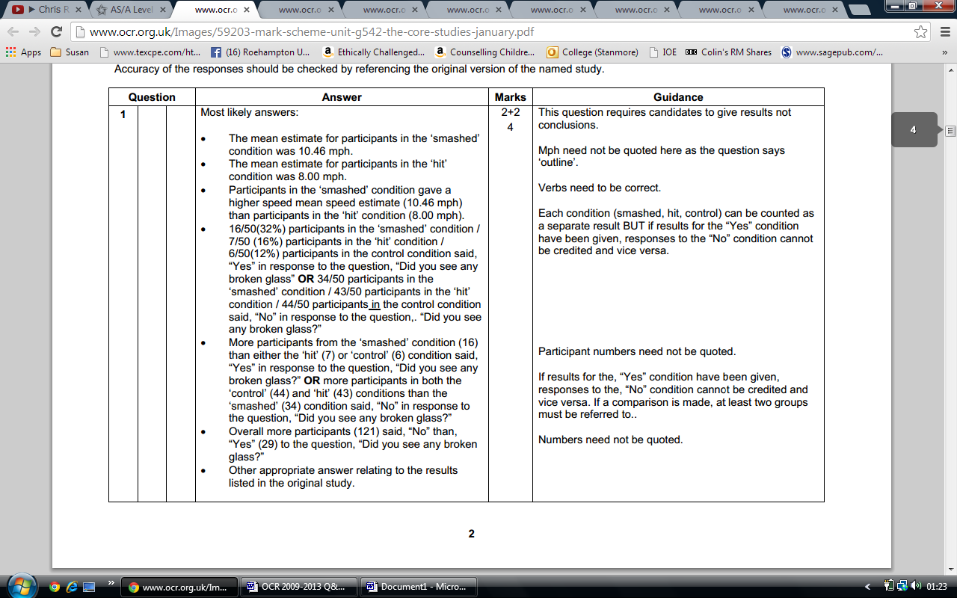

**June 2014**

In their study on eye witness testimony, Loftus and Palmer proposed that two kinds of information form one’s memory of an event.

Describe these two kinds of information in relation to this study. [4]

**Answers**

Most likely descriptions:

* The first is information gleaned during the perception of the original event i.e. whilst watching the film(s) of the car accidents, the second is external information supplied after the fact i.e. through the leading questions in relation the vehicular speed and /or the recollection of seeing broken glass.
* Memory is determined by two sources: (i) one’s own perception gleaned at the time of the original event i.e. whilst watching the film(s) of the car accidents (ii) external information supplied after the fact i.e. though the leading questions in relation to vehicular speed and/or the recollection of seeing broken glass.
* Other appropriate descriptions should be credited.

For emailing

January 2010: 4/4

January 2009

a. 2/2

b. 2/2

June 2009: 4/4

June 2010

a. 2/2

b. 2/2

June 2012: 2/2

January 2011: 4/4

January 2012: 4/4

June 2014: 4/4