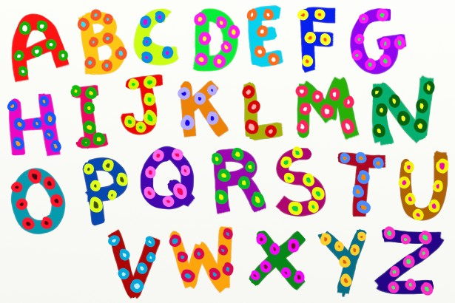Alphabet Task

1. ___________ ____________ ___________

___________ ___________ ___________

2. ___________ ___________ ___________ ___________ ___________ ___________ ____________ ___________

List 1 = ____/ 6 = _____% List 2 = ___ / 6 = ____%

The 4 Main Research Methods

There are 4 ways in which psychologists do research:

1. By asking people questions – but they could lie
2. By watching people – but they might know they are being watched
3. By meddling with them – but is it ethical?
4. By looking at the links between things – do links always show that caused something?

We call these:

1. Self - reports

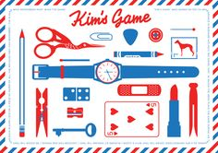2. Observations

3. Experiments

4. Correlations

Kim’s Game

1. ____________________________________
2. ____________________________________
3. ______________________________________________________
4. ______________________________________________________
5. ______________________________________________________
6. ______________________________________________________
7. ______________________________________________________
8. ______________________________________________________
9. ______________________________________________________
10. ______________________________________________________
11. ______________________________________________________
12. ______________________________________________________
13. ______________________________________________________
14. ______________________________________________________
15. ______________________________________________________

True / False and How

|  |  |  |  |
| --- | --- | --- | --- |
| 1. Psychology is an easy subject. | 1. Some people dream at night, other don’t. | 1. Psychologists go around analysing people all the time. | 1. http://www.friday-ad.co.uk/PhotoAds/LandingPages/image/depression.jpgPsychologists are interested in this |
| **True/False** | **True/False** | **True/False** | **True/False** |
| 1. Dynamo Dynamo the Magician attends the UK film premiere of "The Bounty Hunter" at Vue West End on March 11, 2010 in London, England.Psychologists can read people’s minds | 1. The Government, Exam Boards and UCAS classify as a science. | http://images.essentialbaby.com.au/2009/09/15/732242/Naughty-girl_420-420x0.jpg   1. Psychologists are interested in this | 1. Psychology doesn’t involve any maths – so doesn’t matter if I don’t like maths. |
| **True/False** | **True/False** | **True/False** | **True/False** |
| 1. A Levels require you to study just in lessons and for prep | 1. http://diytravelidea.com/wp-content/uploads/201011022230192830.jpgPsychologists are interested in this | 1. Psychologists all have the same views about behaviour | 1. Most psychologists work as therapists or counsellors |
| **True/False** | **True/False** | **True/False** | **True/False** |
| 1. To succeed in Psychology you need to have an open mind | 1. Some people are left-brained (logical), others are right-brained (artistic). | 1. http://www.healblog.net/wp-content/uploads/11.jpgPsychologists are interested in this | 1. Psychology requires lots of long essay writing. |
| **True/False** | **True/False** | **True/False** | **True/False** |
| http://2.bp.blogspot.com/_0KMnzNqRq8Y/S8JFJP75x_I/AAAAAAAAClk/4hKWDQvCfOs/s1600/brain.jpg   1. Psychologists are interested in this | 1. By studying Psychology A Level, I will learn how to lie effectively and how to pull women/men | 1. Psychology involves getting evidence to support your ideas http://www.georgetandy.com/evidence_low_resolution-blk-alpha.jpg | 1. http://talkleft.com/lineup.jpgPsychologists are interested in this |
| **True/False** | **True/False** | **True/False** | **True/False** |

C:\Documents and Settings\vevagora\Local Settings\Temporary Internet Files\Content.IE5\H6ATT5IA\MC900434713[1].wmfWhat kind of psychologist will you be?

Tick the answer which apply to you: a, b, c, or d

1. When recruiting people for your experiment do you:
2. Give them all the information you can and explain it in detail
3. Give them a consent form to sign and then ignore it completely
4. Don’t give them a consent form because you need to deceive them
5. Feel very pleased about lying to and deceiving them
6. When you design your experiment do you:
7. Try to avoid any research where someone might break a nail, never mind deception
8. Recruit students, sixth formers, and other powerless people because you think your research is the most important thing
9. Know that deception is part of your field of work but make sure everyone is looked after well and has counselling if they need it
10. Deception, that’s how I make my living, go away minions…
11. Do you tell people from the start that they have a right to withdraw from the experiment at any time?
12. Yes, I absolutely make it clear every single time
13. I try to, but sometimes I forget and my girlfriend has to remind me
14. No because it would ruin my experiment, they have to obey!
15. Excuse me, I have a contract to fulfil, are you mad?
16. Do you keep people’s details confidential?
17. Yes, always because I am aware of their human rights and the Data Protection Act
18. They are nameless, but I included details of their humiliation in my book, and on documentaries, but it was all done in the name of science and not for me, honest!
19. Yes, but there are still photos around
20. Are you stupid? I have to think of higher things like book deals, tours, after dinner speaking etc….
21. Do you protect your participants from physical or psychological harm
22. I try very hard to do no harm
23. Most of them, but you have to break eggs to make an omelette
24. Yes, everyone had debriefing and I had counsellors on standby any time they needed it
25. Are you some kind of killjoy? Do you understand entertainment at all?

*Now add up the numbers of your a, b, c, or d and find out which psychologist you are:*

What kind of psychologist will you be?

We are meeting her in March

[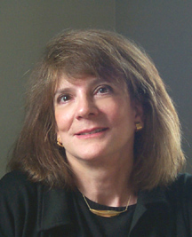](http://faculty.washington.edu/eloftus/Images/Elizabeth%20F.%20Loftus%20UCI.jpg)**MOSTLY A**

You are most likely going to turn into **Professor Elizabeth Loftus.** Elizabeth works on making Eyewitness testimony better so that only the right people go to Prison. Her experiment showed that Eyewitnesses are not very good at remembering details when under stress.

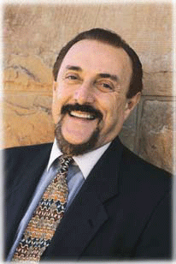

**MOSTLY B**

We met him this year

You are most likely going to turn into **Professor Philip Zimbardo**. He did the famous Stanford Prison experiment to show how social roles change behaviour. He got so carried away with the experiment he lost sight of the effects on participants until his girlfriend, also a psychologist stepped in and stopped him. Dr Phil is everywhere on the net so he did rather well out of it all…

**[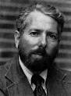](http://www.google.co.uk/imgres?imgurl=http://eweb.furman.edu/~einstein/general/social/milg.jpg&imgrefurl=http://www.furman.edu/~einstein/general/social/milgram.htm&usg=__AK4VcvxuUFdN6aQA8EQTz67wJ8Q=&h=389&w=288&sz=11&hl=en&start=4&sig2=7w6vxj7z8LBHHRcukB8Yyg&zoom=1&tbnid=qVv8Gl2ueXxwkM:&tbnh=123&tbnw=91&ei=3-72T-eRNsaB8gPQyPiEBw&prev=/search?q=stanley+milgram&hl=en&safe=vss&gbv=2&tbm=isch&itbs=1)MOSTLY C**

You are probably going to turn into **Stanley Milgram**. His parents were Jewish Refugees during the war. He watched the trial of Adolph Eichmann whose defence for atrocities toward Jews was “I was only obeying orders” He set up an experiment to test this. He had to deceive participants but was uncomfortable about it

[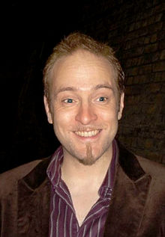](http://en.wikipedia.org/wiki/File:Derren_Victor_Brown.jpg)

**MOSTLY D**

You wish you could turn into **Derren Brown.** You know a lot about the application (some would say misapplication) of psychology. You are highly intelligent, but because your laboratory is the TV and your audience will pay, you are not subject to the ethical codes that the rest of the psychological world is constrained by.