Freud Prep Exam Practice: 25 marks

1. Explain one strength and one weakness of the ‘case study’ research method used by Freud. [6] (Jan 2011)

2. From Freud’s case study of Little Hans,

1. Describe how the data was collected. [2]
2. Suggest one problem with the way Freud interpreted the data. [2] (June 2012)

3. Referring to Freud’s case study of Little Hans

1. Explain the key features of the Oedipus Complex. [4]
2. Outline one piece of evidence from the study which supports the suggestion that Hans was a ‘little Oedipus’. [2] (June 2012)

4. From Freud’s case study of Little Hans,

1. Briefly describe one of Little Hans’ dreams or fantasies. [2]
2. Outline Freud’s explanations of this dream or fantasy. [2] (June 2009)

5. Summarise Freud’s case study of Little Hans into 5 marks worth of material (aim, sample, procedure, results, conclusions). [5]

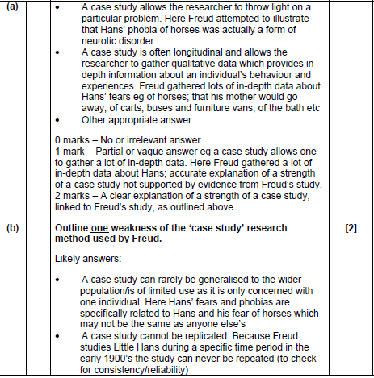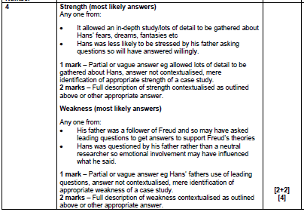

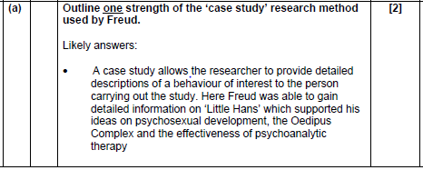

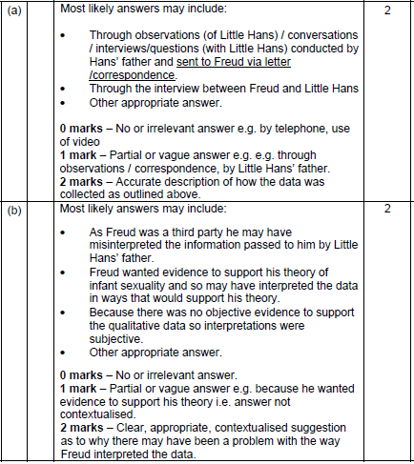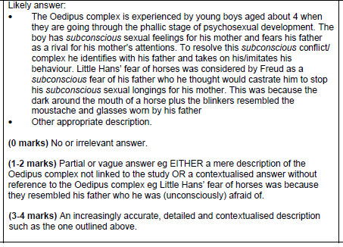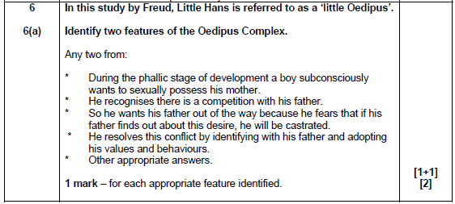

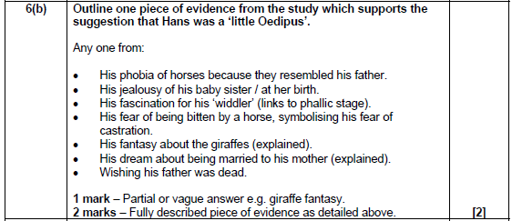

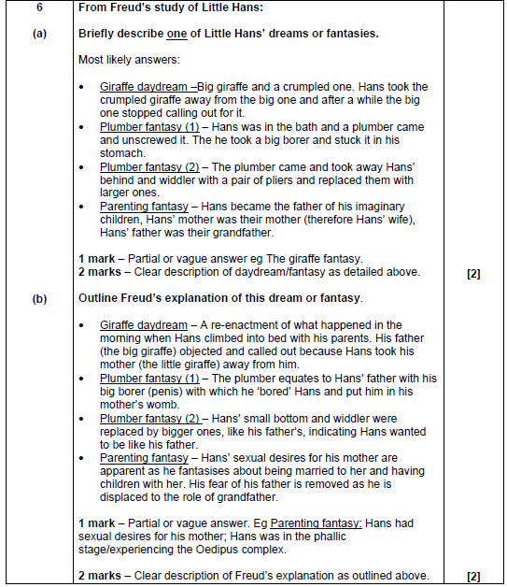

|  |  |
| --- | --- |
| **FREUD: Analysis of a phobia in a 5 year old boy** | |
| **Aims:** To give an account of a boy who was suffering from a phobia of horses and range of other symptoms, and to use this case to illustrate the existence of the Oedipus Complex. | **Design:** A clinical case study – the participant is a patient undergoing therapy. In this case, Freud’s direct input was very limited; Freud met Hans no more than twice. Han’s father conducted regular discussions with Freud, who analysed the information in line with his theory. |
| **Participant:** A Jewish boy from Vienna named Hans, aged 5 years old at the start of the study (real name Herbert Graf). Little Hans was suffering with a phobia of horses, his father, a fan of Freud, referred the case to Freud and went on to provide the case information. | |
| **Case History:**   * When the child took an interest in his ‘widdler’ – he played with it regularly, his mother became cross and threatened to send for a doctor to cut it off. This upset Hans and he developed a fear of castration – which meant he had to repress his feelings of pleasure. * At around the same time, he saw a horse collapse and die in the street and was very distressed by this. * Noticed that animals had large ones i.e. horses, assumed both his parents must have large ones. * At 3 ½ his sister was born. * At 4, Hans developed a fear of horses, specifically that a white horse would bite him. Han’s father noted to Freud that his fear seemed to relate to the size of the horses penis and his dissatisfaction with the size of his own penis. * At around the same time his phobia developed, a conflict also developed with his father over Han’s climbing into his parents bed in the morning to cuddle his mother, Han’s father objected to this. Han’s phobia worsened to the extent that he did not want to leave the house. He also suffered attacks of generalised anxiety. * Hans had a fantasy about two giraffes, one cried out to the other. * By age 5 Hans’ phobia lessened, becoming limited to white horses who wore a noseband and blinkers, which were likened by Freud to Hans’ father’s moustache and glasses. The phobia then disappeared altogether. * The end of the phobia was marked by two fantasies: he fantasised he had several children: when his father asked who the other was, Hans’ replied “Mummy, and you’re the Granddaddy”. * The next day Hans’ fantasised that plumber had come and removed his bottom and penis replacing them with new and larger ones. | |
| **Results:**  Freud interpreted the case as an example of the Oedipus complex, specifically:   * Horses represented Hans’ father * Horses made good father symbols because they have large penises * The anxiety Hans felt was really castration anxiety, triggered by his mother’s threat to ‘cut off his penis’ and a fear of his father caused by his banishing of Hans from the marital bed. * The giraffes in Hans’s fantasy represent his parents. The large giraffe that cries out represented Hans’ father objecting to having Hans in the bed, and the crumpled giraffe was his mother, crumpled representing her genitals. The large giraffe with its erect neck could have symbolised his father’s penis. * The children fantasy represents a friendly resolution of the Oedipus complex in which Hans replaces his father as his mother’s main love object, but the father still had a role. * The plumber fantasy represents identification with the father – he sees himself growing a large penis like his father and becoming like him. | |

**The Individual Differences Area**

Some people that all humans behave in the way and react to situations and experiences in a way. In reality, the human experience is so complex that it is an of lots of variables within a person’s life that their behaviour and cause them to differ from the next person. Individual differences researchers aim to what the differences are among people and why they have these differences. Models of are used to understand the differences that occur in a particular behaviour, such as or autism.

Behaviour Developed Establish

Influence Interaction Same

Schizophrenia Think Universal

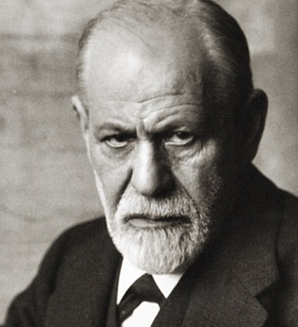

**Why Freud is in the Individual Differences area**

*Cross out the word in the pair which is incorrect*

because of its **focus/vagueness** on trying to **explain/create** a way in which people may differ – by having **phobias/autism**. It does this through the case **observation/study** of a single **girl/boy**.

**Principles of the Psychodynamic Perspective**

Personality is by relationships, and conflict over time, especially during . Different parts of the mind are in constant struggle with each other and the consequences of this are often shown through . The mind is like an iceberg. We have conscious, subconscious and unconscious , all of which can influence our behaviour.

Behaviour Childhood Dynamic

Experience Shaped Thought

**Why Freud is in the Psychodynamic perspective**

*Cross out the word in the pair which is incorrect*

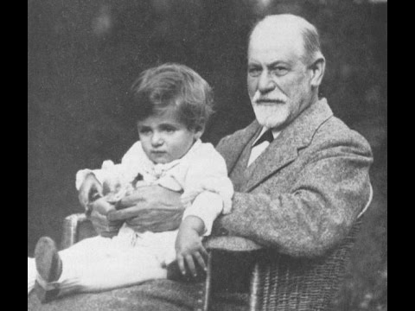

Freud is placed in the **behaviourist/psychodynamic** because of the way in which **Adler’s/Freud’s** theory of psychosexual **development/models** (especially the Oedipus **fixation/complex**) is drawn upon to explain little Hans’ phobias and **twitches/fantasies**.

**Answers**

**The Individual Differences Area**

Some people think that all humans behave in the same way and react to situations and experiences in a universal way. In reality, the human experience is so complex that it is an interaction of lots of variables within a person’s life that influence their behaviour and cause them to differ from the next person. With this in mind, individual differences researchers aim to establish what the differences are among people and why they have developed these differences. Models of behaviour are used to understand the differences that occur in a particular behaviour, such as schizophrenia or autism.

**Assumptions of the Individual Differences Area**

* Individuals differ in their behaviour and personal qualities so not everyone can be considered ‘the average person’.
* Every individual is genetically unique and this uniqueness is displayed through their behaviour. So everyone behaves differently.
* All human characteristics can be measured from one person and quantified. The measures gained from one person are different to those gained from another.
* All psychological characteristics are inherited and as everyone inherits different characteristics, everyone is different and unique.

Freud is placed in the Individual Differences area because of its focus on trying to explain a way in which people may differ – namely, by having phobias. It does this through the case study of a single boy.

**Assumptions of the Psychodynamic Perspective**

Personality is shaped by relationships, experience and conflict over time, especially during childhood. Different parts of the mind are in constant dynamic struggle with each other and the consequences of this are often shown through behaviour. The mind is like an iceberg. We have conscious, subconscious and unconscious thought, all of which can influence our behaviour.

**Freud is placed in the p**sychodynamic because of the way in which Freud’s theory of psychosexual development (especially the Oedipus complex) is drawn upon to explain little Hans’ phobias and fantasies.

**Key questions on the study**

1. What causes Hans to develop a fear of castration?

|  |
| --- |
|  |

2. What real-life event could be linked to his phobia of horses?

|  |
| --- |
|  |

3. What was the conflict that had developed between Hans and his father?

|  |
| --- |
|  |

4. Describe why Freud suggested that Hans’ fear of horses represented his father?

|  |
| --- |
|  |

5. Outline one dream had by Little Hans.

|  |
| --- |
|  |

6. Outline one fantasy had by Little Hans.

|  |
| --- |
|  |

Answers

1. What causes Hans to develop a fear of castration?

His mother threatened to call a doctor to ‘cut-it off’ because he had been playing with it.

2. What real-life event could be linked to his phobia of horses?

Hans saw a horse collapse in the street, and was very distressed by this.

3. What was the conflict that had developed between Hans and his father?

Hans liked to climb into his parent’s bed each morning and cuddle his mother- his father objected to this, and stopped Hans from doing it.

4. Describe why Freud suggested that Hans’ fear of horses represented his father?

The horse that Hans was scared of was white, with blinkers and a nose strap- this was though to symbolise his father’s pale skin, glasses and moustache.

5. Outline one dream had by Little Hans.

Little Hans dreamed that two giraffes were in his room one night, a tall one and a crumpled one. Hans took the crumpled giraffe away from the large one, which cried out.

6. Outline one fantasy had by Little Hans.

Hans had a fantasy that a plumber came and removed his bottom and penis, and replaced them with larger ones.

Symbolism of Little Hans’ Dreams, Fantasies and Phobias

|  |  |
| --- | --- |
| Symbol | Meaning |
| C:\Users\vevagora\AppData\Local\Microsoft\Windows\Temporary Internet Files\Content.IE5\LAHNVWGJ\horse_lineart_by_8_tigereyes_8[1].png |  |
| https://imgs-steps-dragoart-386112.c.cdn77.org/how-to-draw-a-simple-giraffe-step-7_1_000000024729_5.jpg |  |
| https://s3.amazonaws.com/up.411.ca/100/557/8247.jpg |  |
| http://image.shutterstock.com/z/stock-photo-hand-line-drawing-sticky-figures-of-a-family-parents-children-pet-243610762.jpg |  |

|  |  |  |  |
| --- | --- | --- | --- |
| When Little Hans took an interest in his ‘widdler’ – he played with it regularly, his mother became cross and threatened to send for a doctor to cut it off. This upset Hans and he developed a fear of castration – which meant he had to repress his feelings of pleasure. | At around the same time, he saw a horse collapse and die in the street and was very distressed by this. Little Hans noticed that animals had large ones i.e. horses, assumed both his parents must have large ones. | | At 3 ½ his sister was born. This was a further cause for separation between him and his mother and he expressed hostility towards his new sister Hannah. Hans had previously liked having a bath but now said he was afraid that his mother would drop him when she was bathing him. |
|  |  | |  |
| When his father talked to him about this Hans admitted that he had watched his sister having a bath and wished his mother would let her go. This unconscious desire became translated into a fear that his mother might equally let Hans go. | At 4, Hans developed a fear of horses, specifically that a white horse would bite him. Han’s father noted to Freud that his fear seemed to relate to the size of the horses penis and his dissatisfaction with the size of his own penis. | | At around the same time his phobia developed, a conflict also developed with his father over Han’s climbing into his parents bed in the morning to cuddle his mother, Han’s father objected to this. Han’s phobia worsened to the extent that he did not want to leave the house. He also suffered attacks of generalised anxiety. |
|  |  | |  |
| Hans had a fantasy about two giraffes, one cried out to the other. Hans took away the  crumpled one and this made the big one cry out. Hans sat down on the crumpled one. | Hans’ father said this represented that Hans liked to get into his parents’ bed but his father (the big giraffe) often objected. Hans took away his mother (the crumpled one) which caused his father to cry out. Hans sat on top of his mother to claim her for himself. | By age 5 Hans’ phobia lessened, becoming limited to white horses who wore a noseband and blinkers, which were likened by Freud to Hans’ father’s moustache and glasses. The phobia then disappeared altogether. | |
|  |  |  | |
| The end of the phobia was marked by two fantasies: he fantasised he had several children: when his father asked who the other was, Hans’ replied “Mummy, and you’re the Granddaddy”. | The next day Hans’ fantasised that plumber had come and removed his bottom and penis replacing them with new and larger ones. | This led Freud to conclude that Hans had at last overcome his Oedipus complex and was now able to identify with his father. | |
|  |  |  | |

Little Hans Multiple Choice Quiz

1. According to Freud, the unconscious mind is...

1. The 90% of the mind that is not used
2. The part of the mind that is active when you are asleep
3. The part of the mind you use when you are concentrating
4. Thoughts and desires that you are not aware of

2. Which perspective does the study fall under?

1. Behaviourist
2. Biological
3. Developmental
4. Psychodynamic

3. What type of research method was used?

1. Case Study
2. Field Experiment
3. Observation
4. Quasi experiment

4. Which part of the unconscious mind forms the conscience?

1. Ego
2. Id
3. Superego
4. Ultra-ego

5. Which stage of psychosexual development did Freud suggest Little Hans was in?

1. Genital
2. Latent
3. Oral
4. Phallic

6. Which of these things did 'Little Hans' not develop a phobia of?

1. Baths
2. Castration
3. Giraffes
4. Horses

7. Which data collection methods were used in the study?

1. Field Experiment and Observation
2. Lab experiment and Observation
3. Observation and self-report
4. Self-report and Correlation

8. What, according to Freud caused Hans' fear of Horses?

1. Desire to drown his sister Hanna
2. Hans thought his father would take his mother away
3. Hearing a man tell his son the horse would bite his finger
4. Seeing a horse and cart fall over in the street

9. According to Freud, Hans resented his sister because...

1. She cried throughout the night
2. She kept playing with his toys
3. She was a rival for his father’s attention
4. She was a rival for his mother's attention

10. Which fantasy / dream demonstrated to Freud that Little Hans had overcome his Oedipus Complex?

1. Bath fantasy where mum drops Hanna
2. Fantasy of the cart toppling over
3. Giraffe fantasy, where Mum giraffe was all crumpled
4. Plumber replacing his widdler with a new one

Little Hans and the Oedipus Complex

|  |  |  |  |  |  |  |  |  |  |  |  |  |  |  |  |  |  |  |  |
| --- | --- | --- | --- | --- | --- | --- | --- | --- | --- | --- | --- | --- | --- | --- | --- | --- | --- | --- | --- |
| H | A | T | O | R | H | I | T | R | D | D | N | S | H | H | M | S | R | F | S |
| O | E | S | A | S | J | R | R | R | E | O | T | P | E | O | L | D | J | F | I |
| D | E | T | C | E | J | O | R | P | A | H | R | D | C | S | S | E | A | T | I |
| T | R | P | I | N | C | N | O | H | U | N | T | A | S | J | U | C | I | E | M |
| C | R | E | W | C | T | S | L | J | U | H | S | O | U | U | P | W | W | C | S |
| R | N | O | H | H | T | X | T | H | L | E | S | F | M | E | I | E | I | N | P |
| R | I | P | P | T | N | H | J | L | A | T | N | O | E | A | D | C | T | S | H |
| S | L | S | U | P | A | O | H | N | T | H | E | I | R | R | E | W | F | O | H |
| O | S | C | U | L | U | F | M | T | E | O | B | L | I | E | O | C | F | G | T |
| E | R | E | Y | R | C | S | I | M | P | R | A | C | H | M | E | R | W | Y | H |
| O | N | S | R | C | I | H | E | A | E | S | A | E | R | G | E | E | R | T | O |
| D | N | E | A | P | H | A | S | A | R | E | N | W | C | O | A | E | S | L | A |
| E | A | T | A | H | X | B | T | T | Y | S | R | R | E | I | H | H | O | S | A |
| N | O | E | H | T | R | E | Y | L | A | V | I | R | O | T | O | T | D | E | H |
| E | D | P | D | O | U | O | T | P | E | T | A | G | O | H | A | A | A | O | E |
| I | O | E | S | T | H | D | F | T | O | L | E | M | A | T | L | L | A | Y | N |
| E | H | D | R | A | T | T | O | D | H | E | D | N | E | C | L | R | E | P | F |
| D | D | R | E | D | U | E | T | A | U | S | A | A | T | R | E | W | T | H | D |
| M | F | I | O | T | M | M | L | E | I | E | S | E | S | T | T | O | N | S | S |
| E | N | P | A | T | V | I | H | P | L | N | W | E | T | D | H | N | F | E | R |

Freud felt that the \_\_\_\_\_\_\_ study of Hans provided \_\_\_\_\_\_\_\_\_\_\_\_\_ for his idea of the \_\_\_\_\_\_\_\_\_\_\_\_\_ complex. Hans had a \_\_\_\_\_\_\_ to be close to his \_\_\_\_\_\_\_\_\_\_\_ which set him as a \_\_\_\_\_\_\_\_\_ to his father. Hans wished him gone \_\_\_\_\_\_\_, but he could not \_\_\_\_\_\_\_\_\_\_\_\_\_ this directly, so he \_\_\_\_\_\_\_\_\_\_\_\_\_\_\_\_\_ it onto a fear of \_\_\_\_\_\_\_\_\_\_\_. Successful resolution of the Oedipus conflict came when Hans was able to express his feelings about his \_\_\_\_\_\_\_\_\_\_\_ and was able to \_\_\_\_\_\_\_\_\_\_\_\_\_\_\_ his identification from his \_\_\_\_\_\_\_\_\_\_\_ to his father.

Case

‘Dead

Denial

Ego’

Electra

Express

Father

Horses

Mother

Mother

Oedipus

Projected

Rival

Support

Transfer

Wish

Answers

Freud felt that the **case** study of Hans provided **support** for his idea of the **Oedipus** complex. Hans had a **wish** to be close to his **mother**. This set Hans up as a **rival** to his father and he wished him gone (**dead)**. But he could not **express** this directly. Instead he **projected** it onto a fear of **horses**. Successful resolution of the Oedipus conflict came when Hans was able to express his feelings about his **father** and finally able to **transfer** his identification from his **mother** to his father.

Freud felt that the (case) study of Hans provided (support) for his idea of the (Oedipus) complex. Hans had a (wish) to be close to his (mother) which set him as a (rival) to his father. Hans wished him gone (dead), but he could not (express) this directly, so he (projected) it onto a fear of (horses). Successful resolution of the Oedipus conflict came when Hans was able to express his feelings about his (father) and was able to (transfer) his identification from his (mother) to his father.

Answers

|  |  |  |
| --- | --- | --- |
| **Point/ Theme** | **Explain (How/ why is it a strength/ weakness? Use key terminology)** | **Example (Give a specific example from the study…)** |
| **The research method (case study** | A strength of a case study is that we can collect lots of rich detailed information on the Ps, which develops understanding of development | For example, we are able to study Little Hans in lots of detail in order to understand how his phobia developed and was resolved. |
| A disadvantage of a case study is that it is non-experimental, so we cannot infer cause and effect due to the lack of control over other variables that could have caused the behaviour. | For example, we cannot conclude that the phobia was caused by the Oedipus complex, and we do not have enough control over other things such as his experience with the horse in the street. |
| **Sampling Bias** | A case study relies on a very small sample, and therefore we cannot generalise beyond the sample- there is a lack of external validity. | For example, Little Hans was one boy from Vienna, therefore we cannot generalise beyond this- he does not represent all other children. |
| **Qualitative data** | Rich in detail- allowing insightful interpretations of development | For example, we are able to study Little Hans in lots of detail in order to understand how his phobia developed and was resolved. |
| However, qualitative data is subjective and therefore can be prone to bias which reduces the internal validity of the data. | For example, Freud could have interpreted the evidence in line with his theory- researcher bias. |
| **Ethics** | As the research was conducted on a child, informed consent is required from a parent. | For example, Hans’ father provided informed consented and gave Freud lots of information on his son. |
| Due to the nature of the study, there may have been an invasion of privacy and psychological harm. | For example, Han’s father gathered lots of data from his son through intense questioning over personal matters. |
| **Validity** | Lack of external validity | For example, the sample of consisted of a single individual, with a specific phobia. Therefore, we cannot generalise the findings to other disorders and to a wider population. |
| Lack of internal validity caused by demand characteristics, and also researcher bias. | For example, Little Hans may have been affected by leading questions from his father, so answered in a way that would please him. This reduces internal validity, as his answers may not be his true thoughts. |

|  |  |  |
| --- | --- | --- |
|  | A case study relies on a very small sample, and therefore we cannot generalise beyond the sample- there is a lack of external validity. | For example, Freud could have interpreted the evidence in line with his theory- researcher bias. |
|  | A disadvantage of a case study is that it is non-experimental, so we cannot infer cause and effect due to the lack of control over other variables that could have caused the behaviour. | For example, Han’s father gathered lots of data from his son through intense questioning over personal matters. |
|  | A strength of a case study is that we can collect lots of rich detailed information on the Ps, which develops understanding of development | For example, Hans’ father provided informed consented and gave Freud lots of information on his son. |
|  | As the research was conducted on a child, informed consent is required from a parent. | For example, we are able to study Little Hans in lots of detail in order to understand how his phobia developed and was resolved. |
|  | Due to the nature of the study, there may have been an invasion of privacy and psychological harm. | For example, we are able to study Little Hans in lots of detail in order to understand how his phobia developed and was resolved. |
|  | However, qualitative data is subjective and therefore can be prone to bias which reduces the internal validity of the data. | For example, we cannot conclude that the phobia was caused by the Oedipus complex, and we do not have enough control over other things such as his experience with the horse in the street. |
|  | Lack of external validity | For example, Little Hans may have been affected by leading questions from his father, so answered in a way that would please him. This reduces internal validity, as his answers may not be his true thoughts. |
|  | Lack of internal validity caused by demand characteristics, and also researcher bias. | For example, Little Hans was one boy from Vienna, therefore we cannot generalise beyond this- he does not represent all other children. |
|  | Rich in detail- allowing insightful interpretations of development | For example, the sample of consisted of a single individual, with a specific phobia. Therefore, we cannot generalise the findings to other disorders and to a wider population. |

|  |  |  |
| --- | --- | --- |
| **Point/ Theme** | **Explain (How/ why is it a strength/ weakness? Use key terminology)** | **Example (Give a specific example from the study…)** |
| **The research method (case study** |  |  |
|  |  |
| **Sampling Bias** |  |  |
| **Qualitative data** |  |  |
|  |  |
| **Ethics** |  |  |
|  |  |
| **Validity** |  |  |
|  |  |

**Paper 2 Section A**

Short answer questions on the Core Studies. For example:

1. Describe one of Hans’ phobias. [2]
2. Describe Freud’s interpretation of one of Hans’ phobias. [2]

Strategies for this part of the exam

**Paper 2 Section B**

Longer answer questions on the areas, perspectives and debates. For example:

1. Describe **two** principles or concepts of the psychodynamic perspective [4]
2. Outline how Freud’s study links to the psychodynamic perspective. Support your answer with evidence from this study. [4]
3. Discuss the strengths and weaknesses of taking a deterministic perspective in psychology. Use examples from appropriate core studies to support your answer. [15]

Strategies for this part of the exam

**Paper 2 Section C**

Relating your knowledge of the Core Studies to a specific story.

Michael’s grandmother had a fear of spiders and my mother too told me that she didn’t like the way they moved with their long hairy legs. As neither of them could go anywhere near a spider, I grew up believing that this was a story that my mother used to frighten me. Certainly, it was a strategy to keep me away from all bugs in the garden. They did not want me to pick up worms, woodlice and so on. Therefore by the time I was sixteen, I was afraid of spiders.

**a. Identify the psychological content/issue/problem [3]**

**b. Outline psychological research and how it relates to this issue [5]**

**c. Show application to real life by explaining how the situation could be managed [5]**

**d. Evaluate your suggestion [10]**

Strategies for this part of the exam

Paper 2 Section C Style Questions

**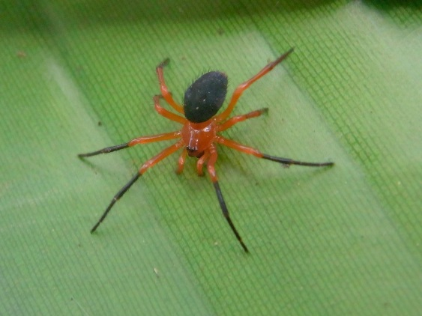**Michael’s grandmother had a fear of spiders and my mother too told me that she didn’t like the way they moved with their long hairy legs. As neither of them could go anywhere near a spider, I grew up believing that this was a story that my mother used to frighten me. Certainly, it was a strategy to keep me away from all bugs in the garden. They did not want me to pick up worms, woodlice and so on. Therefore by the time I was sixteen, I was afraid of spiders.

1. **Explain the psychological content/issue/problem of this article. [3]**

The first thing to do is to highlight the key words and phrases that could be evidence of a particular perspective, key theme or psychological theory.

For example you could highlight by the time I was sixteen, I was afraid of spiders as it could be suggested that the childhood experiences of Michael being frightened by his mother due to her dislike of their long hairy legs meant he developed his fear of spiders.

1. **Outline one piece of psychological research which relates to this article and explain and how it relates to the issue you have identified. [6]**

Describe the psychological research referring to its aim, sample, procedure, results and conclusions. Then show how it that supports the issue you have identified - using the evidence you have highlighted.

For example using Freud’s psychodynamic theory to show that a child’s early experiences will shape its behaviour in later life, in this case Michael’s fear of spiders due to a story that was used to frighten.

1. **Outline one strategy which psychologists could use to manage Michael’s phobia of spiders. [5]**

Freud’s psychodynamic approach has provided therapies mainly through talking cures that have enabled individuals to cope with earlier traumatic experiences and Michael could be referred for this kind of therapy.

* Explain WHAT you want to change and HOW you will change it
* Know the types of application (prevention, intervention, treatment, therapy)
* State which type of application it will be.
* The majority of the marks are for HOW you would do it. For example: Social learning (grab their attention, repeat it to keep it in LTM, give them opportunity to reproduce it, with a motivation (vicarious or not).

1. **Evaluate your strategy suggested in Q3. [10]**

A problem is that there is an assumption that the phobia of spiders stems from Michael’s unconscious but it could be learned or inherited. His parents also had phobic behaviours and so Michael may have inherited this personality trait which couldn’t be changed. On the other hand, the behaviourist approach shows that reinforcement could have made Michael afraid of spiders must have been learned and so can be unlearned. As such Michael could be given rewards when he starts to explore bugs in the garden or in Biology lessons at school.

**Examples of Practical evaluative points:**

* Cost: Financial implications
* Resources available
* Co-operation between the agencies/individuals involved
* Time constraints
* Accessibility
* Travel implications
* Ethics