Curiosity

Curious to know more on a topic – use these QR codes for further independent reading.

Biological Psychology
Sperry (1968) – Core study.
Hemisphere deconnection and unity in conscious awareness (full article).
Casey et al (2011) – Core study
Behavioural and neural correlates of delay of gratification 40 years later (full article).
Blakemore and Cooper (1970) – Core study
Impact of early visual experience.
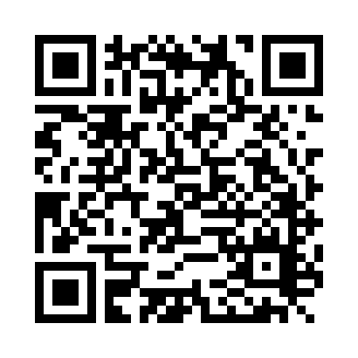 | Maguire et al (2000) – Core study  Navigation-related structural change in the hippocampi of taxi-drivers (full article).
Brain made simple.
A website which simplifies the functions associated with different parts of the brain.
The case of Phineas Gage – Additional reading
A famous case study of how a man’s personality changed following a brain injury.
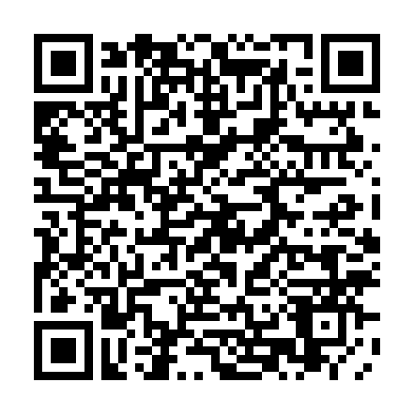 | The case of “Tan” – Additional reading  A famous case study of a man who suddenly lost the ability to speak, apart from the word “tan”.
Cognitive Psychology
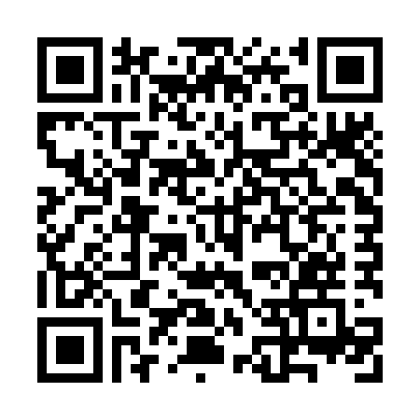 | The case study of HM- Additional reading  A famous case of a man who taught us about memory by losing his own.
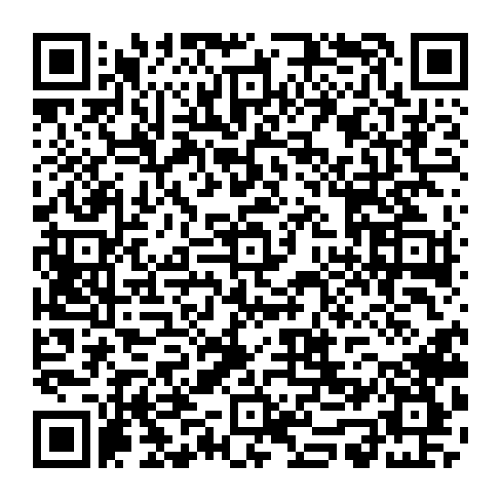 | Loftus and Palmer (1974) – Core study  Reconstruction of automobile destruction: an example of the interaction between language and memory (full article).
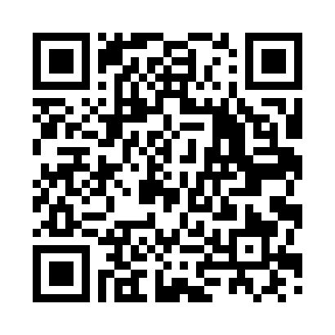 | Grant et al (1998) – Core study  Context-dependent memory for meaningful material: information for students (full article).
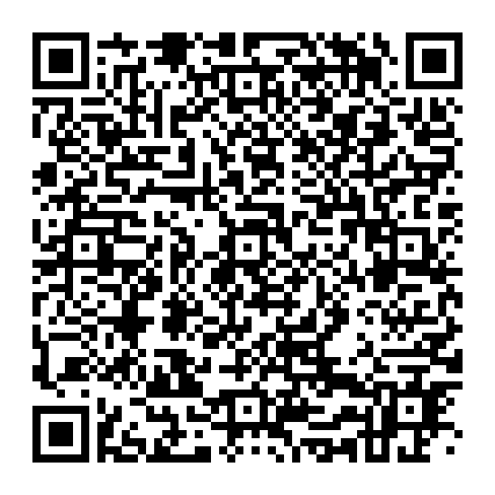 | Simons and Chabris (1999) – Core study  Gorillas in our midst: sustained inattentional blindness for dynamic events (full article).
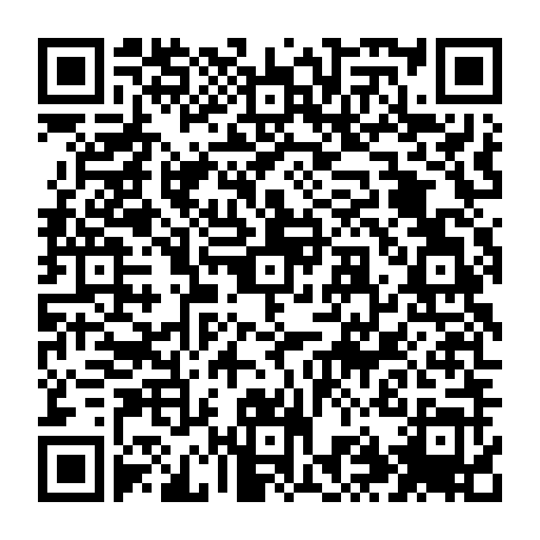 | Moray (1959) – Core study  Attention in dichotic listening: affective cues and the influence of instructions (full article).
Atkinson and Shiffrin (1968) – Additional reading
The multi-store model- a popular theory of how our memory works.
Baddeley and Hitch (1974) – Additional reading
The working memory model- a popular theory of how our memory works.

Criminal Psychology
Raine et al (1997) – Key study
Brain abnormalities in murderers indicated by positron emission tomography (full article)
Hall and Player (2008) – Key study
Will the introduction of an emotional context affect fingerprint analysis and decision-making?
Memon and Higham (1999) – Key study
A review of the cognitive interview (full article).
Dixon et al (2002) – Key study
Accents of guilt? Effects of regional accent, race, and crime type on attributions of guilt (full article)
Wilson and Kelling (1982) – Key study
The police and neighbourhood safety: broken windows (full article).
Haney, Banks and Zimbardo (1973)- Key study
Study of prisoners and guards in a stimulated prison.
Reicher and Haslam (2006) – Additional reading
Rethinking the psychology of tyranny: the BBC prison study.

Child Psychology
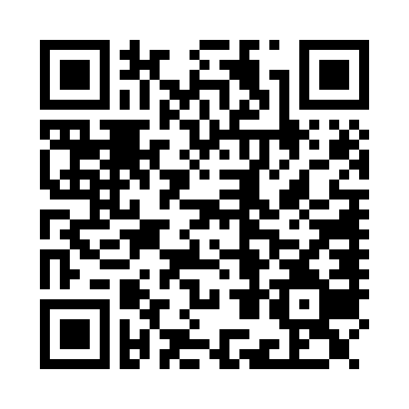 | Van Leeuwen et al (2008) – Key study.  A twin-family study of general IQ (full article).
Barkley-Levenson et al (2014) – Key study
Neural representation of expected value in the adolescent brain (full article).
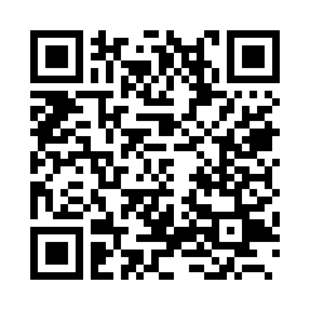 | Gibson and Walk (1960) – Key study  The visual cliff.
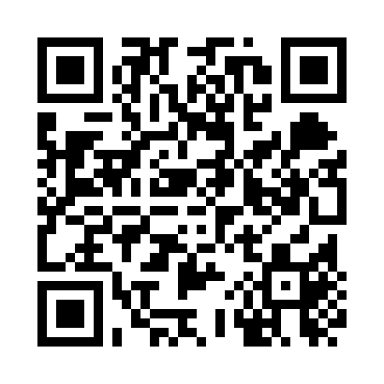 | Wood, Bruner and Ross (1976) – Key study  The role of tutoring in problem-solving (full article).
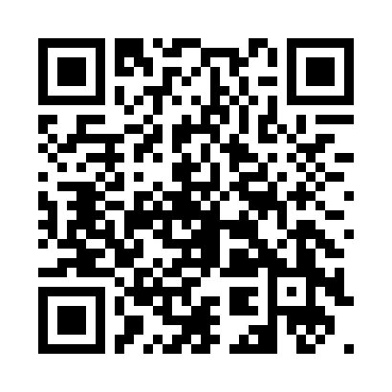 | Ainsworth and Bell (1970) – Key study  Attachment, exploration and separation: illustrated by the behaviour of one-year-olds in a strange situation.
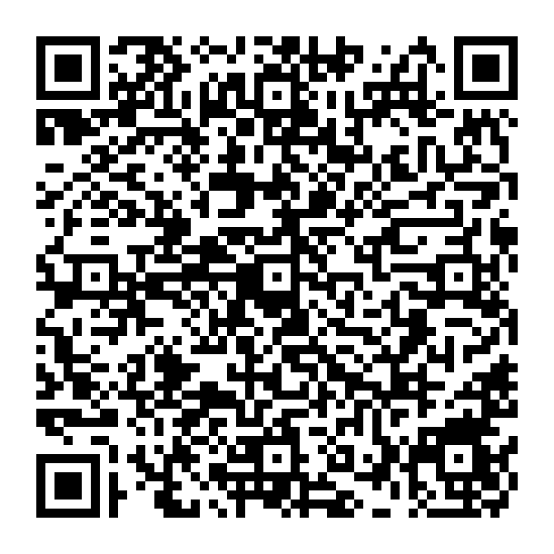 | Johnson and Young (2002) – Key study  Gendered voices in children’s advertising.
 | Piaget’s theory of cognitive development. Additional reading that will be useful for topic 4.

Debates
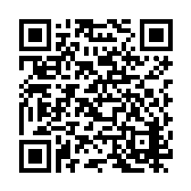 | Reductionism versus holism. Information on the debate and how different areas reflect the debate.
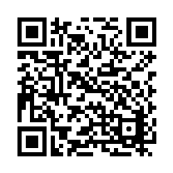 | Free will versus determinism. Information on the debate and how different areas reflect the debate.
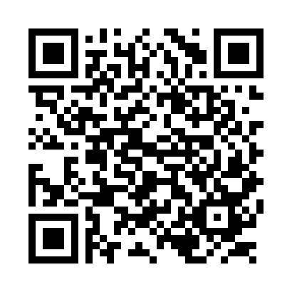 | Individual versus situational. Information on the debate and how the different areas reflect the debate.
 | Nature versus nurture. Information on the debate and how the different areas reflect the debate.
 | Usefulness of research. An article that describes many of the practical uses of psychological research.
 | Ethical considerations. Information on the debate and how the different areas reflect the debate.
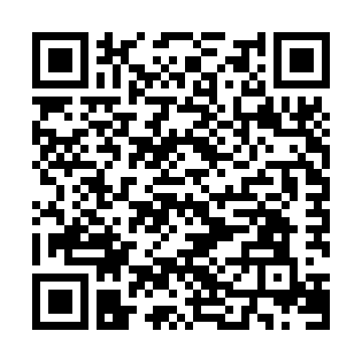 | Socially sensitive research. Information on the debate and how the different areas reflect the debate.
 | Psychology as a science. Information on the debate and how the different areas reflect the debate.

Developmental Psychology
Bandura, Ross and Ross (1961) – Core study
Transmission of aggression through imitation of aggressive models.
Bandura (1977) – Additional reading
Social learning theory
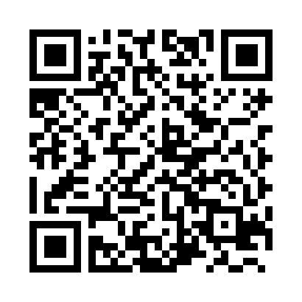 | Chaney et al (2003) – Core study  A new asthma spacer device to improve compliance in children: a pilot study (full article).
Kohlberg (1968) – Core study
The child as a moral philosopher (full article).
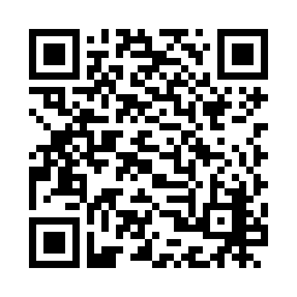 | Lee et al (1997) – Core study  Chinese and Canadian children’s evaluations of lying and truth telling.
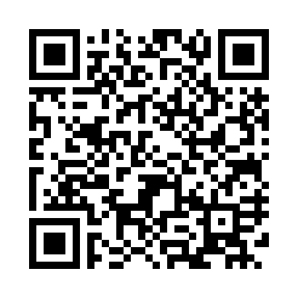 | Bandura et al (1963) – Additional reading  Imitation of film-mediated aggressive models.
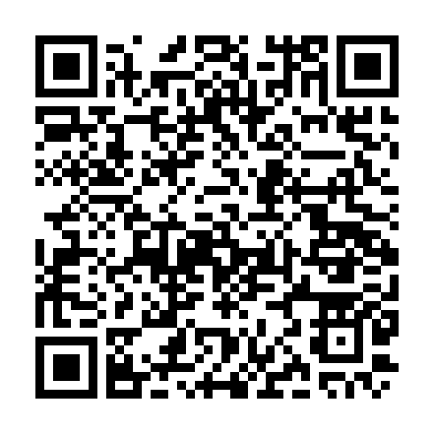 | Behaviourism- explaining operant and classical conditioning. A great resource for additional reading if you’re not sure of the difference.

Individual Differences Area
 | Psychodynamic perspective. This includes explanations of the Oedipus and Electra complexes.
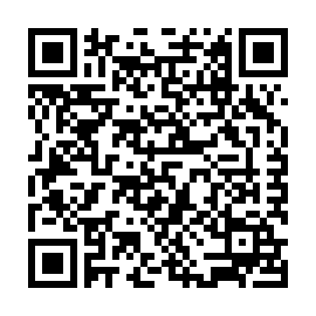 | Autistic Spectrum Disorder (ASD). A useful link to help to provide context to Baron-Cohen et al’s research on theory of mind in individuals with autism.
Freud (1909) – Core study
Analysis of a phobia in a five year old boy (full article).
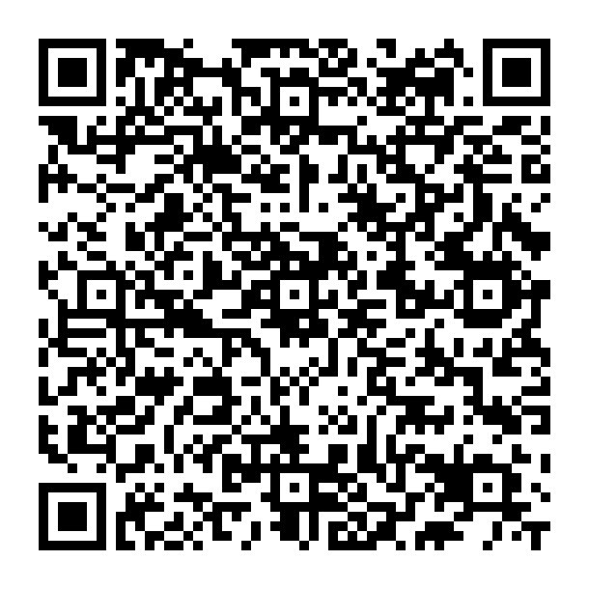 | Baron-Cohen et al (1997) – Core study  Another advanced test of theory of mind: evidence from high functioning adults with autism or Asperger syndrome (full article).
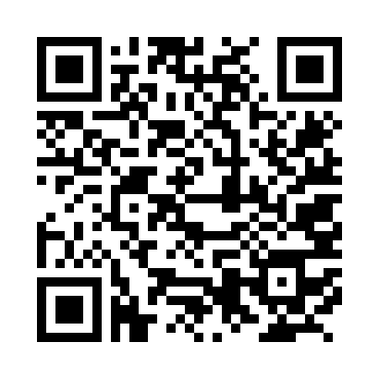 | Gould (1982) – Core study  A nation of morons (full article).
Hancock et al (2013) – Core study
Hungry like the wolf: a word-pattern analysis of the language of psychopaths (full article).
Watson and Rayner (1920) – Additional reading
Conditioned emotional reaction.

Issues of Mental Health
Schizophrenia – Additional reading
A webpage from Mind that describes schizophrenia.
Bipolar disorder – Additional reading
A webpage from Mind that describes bipolar disorder.
Phobias – Additional reading
A webpage from Mind that describes specific phobias.
Rosenhan (1973) – Key study
On being sane in insane places (full article).
Gottesman et al (2010) – Key study
Severe mental disorders in offspring with two psychiatrically ill parents.
Szasz (1960) - Additional reading
The myth of mental illness (full article).
Szasz (2011) – Key study
The myth of mental illness: 50 years later.

Social Area
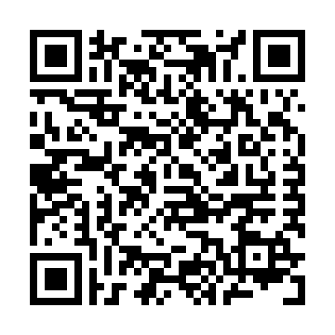 | Latané and Darley (1968) – Additional reading  Experiment to investigate bystander intervention and diffusion of responsibility.
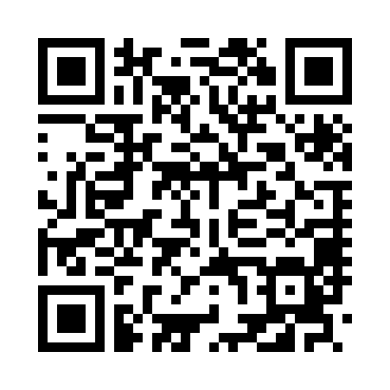 | Milgram (1963) – Core study  Behavioural study of obedience (full article)
Piliavin, Rodin and Piliavin (1969) – Core study
Good samaritanism: An underground phenomenon (full article)
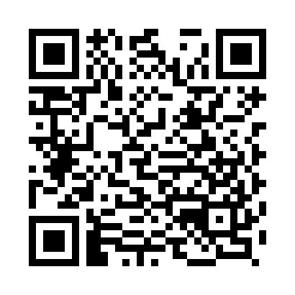 | Levine et al (2001) – Core study  Cross-cultural differences in helping strangers (full article)
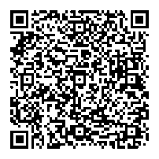 | Sheridan and King (1972) – Additional reading  Obedience to authority with an authentic victim (full article).
Hofling et al (1966) – Additional reading
An experimental study of nurse-physician relationships.
Asch (1951) – Additional reading
Effects of group pressure on the modification and distortion of judgements.

