Psychology prep 25 marks

1. From the study by Baron-Cohen, describe how two of the groups of participants were selected. [4]
2. From the study by Baron-Cohen
   1. Identify the independent variable (IV) and the dependent variable (DV) in the Eyes Task. [2]
   2. Explain why this study is considered a quasi-experiment. [2]
3. In the study by Baron-Cohen, Jolliffe, Mortimore and Robertson, the Ps with autism were found to be unimpaired on two control tasks. Describe these two control tasks. [4]
4. From the study by Baron-Cohen
   1. Identify one of the word pairs in the ‘Eyes Task. [2]
   2. Outline one finding from the ‘Eyes Task’. [2]
5. From the study by Baron-Cohen
   1. Identify one difference between the performance of the autistic adults and the Tourette Syndrome adults. [2]
   2. Outline what this study tells us about advanced theory of mind. [2]
6. Summarise Baron Cohen’s Core Study into 5 marks worth of material (aim, sample, procedure, results, conclusions). [5]

Difficult Words used in Social Intelligence test <http://socialintelligence.labinthewild.org/mite/>

Aghast = filled with horror or shock

Bewildered = confused and indecisive; puzzled.

Despondent = in low spirits from loss of hope or courage.

Dispirited = lost enthusiasm and hope; disheartened

Imploring = begging someone earnestly or desperately to do something.

Incredulous = unwilling or unable to believe something.

Pensive = engaged in, involving, or reflecting deep or serious thought.

Tests for Theory of Mind

**The Sally Anne test**

1. 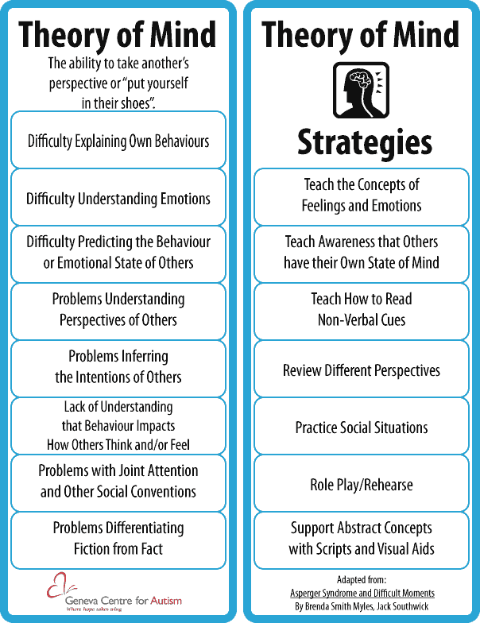Children are presented with two dolls, Sally (who has a basket) and Anne (who has a box).
2. Sally puts a marble in her basket, and leaves the room.
3. While Sally is away, Anne takes the marble from the basket, and hides it in her box.
4. Finally, Sally returns to the room,
5. and the child is asked three questions:
6. 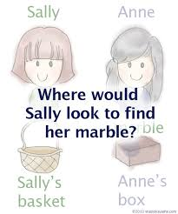Where will Sally look for her marble? (The “belief” question)
7. Where is the marble really? (The “reality” question)
8. Where was the marble at the beginning? (The “memory” question)

**Example of a Happe’s Strange Story: Picnic**

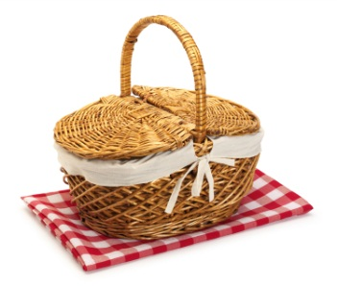Sarah and Tom are going on a picnic. It is Tom's idea, he says it is going to be a lovely sunny day for a picnic. But just as they are unpacking the food, it starts to rain, and soon they are both soaked to the skin. Sarah is cross. She says, "Oh yes, a lovely day for a picnic!"

Is it true, what Sarah says?

Why does she say this?

Research Methods Focus: Design your own method

Write a new ‘strange story’ which could be used with children. [4]

OR

Write the method of a new Sally Anne text which could be used with children. [4]

****Research Methods Focus: Design your own study

On paper 2 section B, you will be asked to design your own study on a topic area.

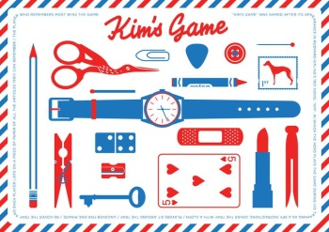

There are 4 types of question you could be asked:

* **Experiment** (like your own experiment on Kim’s Game)
* **Observations** (you did an observation on X factor bad auditions and how your friends present themselves on Facebook)
* **Correlations** (you looked at the number of hours slept and dreams)
* **Self-reports** (you chose to write questionnaire either pets & stress, gender & car colour, weather & mood)

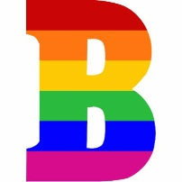

The question is worth 15 marks. For Level 3 (up to Grade B), you will need to repeat the following structure for each of the 4 choices given to you:

**Feature**: I will choose …

**Explained**: The way I am going to do this is …

**Context and Justified:** This would be helpful for this study on …. because

**Own research**: When I did my own study on Facebook impression management, I made the choice to do … and this was helpful because …



For Level 4 (up to grade A*), you will also need to give as much detail as possible into the procedure for someone else to be able to replicate your ideas.

Design an ethical study to show how people with autism will generally experience difficulty in one of the three main areas: Social Communication, Social Interaction and Social Imagination.

**Justify** your decisions as part of your explanation. You must refer to:

* Experiment or correlation
* Upholding ethical guidelines
* How each variable is operationalised
* The inferential statistical test you will use.

You should use your own experience of carrying out an experiment to inform your response. [15]

Design an ethical study to show how people with autism will generally experience difficulty in one of the three main areas: Social Communication, Social Interaction and Social Imagination.

**Justify** your decisions as part of your explanation. You must refer to:

* Experiment or correlation
* Upholding ethical guidelines
* How each variable is operationalised
* The inferential statistical test you will use.

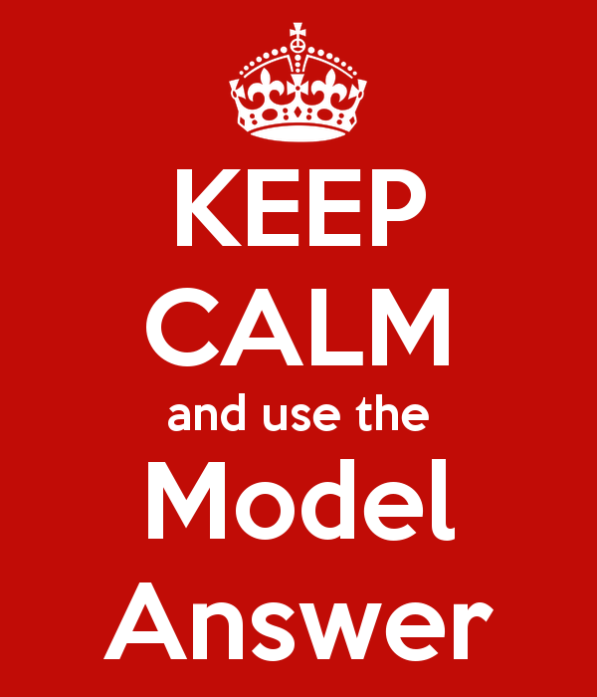You should use your own **experience** of carrying out an experiment to inform your response. [15]

**Bullet point 1**

1. **Feature**: I will do a natural experiment
2. **Explained**: and design a Sally Anne task (describe it here.....)
3. **In context**: to show that people with autism lack understanding of other people’s view.
4. **Justified:** The Sally Anne task will show that lacking a Theory of Mind is the cause and the effect is not being able to imagine what another person is thinking.
5. **Own research**: With my own research doing ‘Kim’s Game’, I showed that practice improves memory.

**Bullet Point 2**

**Feature, explained**: I will gain informed consent from my participants’ parents

**Justified:** because children under 16 cannot consent

**In context**: and autism include an impairment in social interaction.

**Own research**: In class when I wrote a questionnaire, I wrote an informed consent statement before the questionnaire began.

**Bullet point 3**

**Feature, explained & in context**: IV = having autism or not. DV = yes / no / don’t know answers to the Sally Anne test.

**Justified:** This would be helpful for this study on autism because social communication may be impaired.

**Own research**: With my own research doing ‘Kim’s Game’, my DV was operationalised as number of correct items recalled.

**Bullet point 4**

**Feature**: Chi2 will be the statistical test used

**Explained, in context and justified:** because it is a test of difference (natural experiment), the DV will produce nominal data (yes / no / don’t know) and the participants will only complete the Sally Anne task once.

**Own research**: When I did ‘Kim’s Game’, the statistical test used was Mann Whitney U because the data was interval.

**Background**

Autism is a severe developmental disorder which affects the social functioning of individuals. People with Autism share a number of problems in common, known as the “triad of impairments”.

The triad of impairments consists of problems with:

* Social interaction, particularly in forming relationships and lack of eye contact- which can make people with Autism seem aloof or indifferent to others
* Social communication – difficulties with both verbal and non-verbal language, for instance not appreciating the meaning of gestures, facial expressions and tone of voice.
* Social imagination - individuals often have rigid and flexible routines which must be followed strictly, leading to difficulties in imaginative play

Autism runs on a **spectrum** from Asperger syndrome at one end through to individuals showing severe forms of autism at the other extreme.

Baron-Cohen claimed that the numerous deficits that people with autism suffer from can be explained by focusing on the way that they process information. He proposed that they lack a theory of mind– i.e. the ability to recognize and appreciate the mental states (thoughts, desires, fears etc.) of other people. He also refers to this as mind blindness.

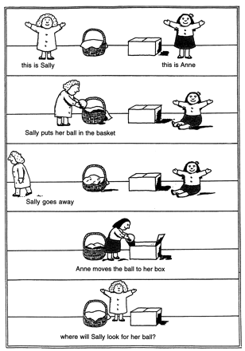

Baron-Cohen argued that impairments in the development of a theory of mind may underlie the social, communicative, and imaginative impairments of people with autism since a theory of mind is necessary for normal development in each of these three areas.

Previous research using first-order tests of theory of mind have demonstrated that children with autism cannot employ a theory of mind. An example of a first-order test is the Sally Anne test.

In this test the child is presented with two dolls (Sally and Anne), a marble, a box and a basket. Sally puts her marble in her basket and leaves the room. Anne then moves the marble from the basket to her box. Sally returns and the child is asked ‘where will Sally look for the marble?’.

Baron Cohen et al. found that normal 4 year old children could correctly state that Sally would look in her own basket whereas children with autism found this first-order belief task difficult (they would point to Anne’s box) which suggests that children with autism cannot employ a theory of mind.

Happe (1994) developed a more advanced theory of mind test called the Strange Stories task designed for the level of a normal 8-9 year old. This task involved story comprehension, where the key question in the task either concerned a character’s mental states (the experimental condition) or physical events (the control condition). It was found that adults with autism had more difficulty with the mental state task than normal control participants.

However, Baron-Cohen argued that the Sally-Anne and Strange Stories tasks could not be used to demonstrate that adults with autism have an intact theory of mind because such tests have a **ceiling effect**. This is because children with normal intelligence can pass such tests at about 6 years of age. In other words, these tests only measure as high as the skills of a normal 6 year old child.

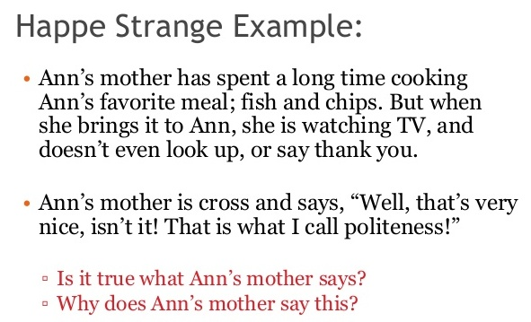

Because the Sally-Anne and Strange Stories tasks were designed for children, Baron Cohen developed a new test called the ‘Reading the Eyes Task’. The task involved inferring the mental state of a person just from the information in photographs of a person’s eyes.

This advanced test aims to discover if high functioning adults with autism have problems with mind reading which it is argued is related to the ability to employ a theory of mind.

**Aim**

The main aim of this experiment was to investigate if high functioning adults with autism would be impaired on a theory of mind test called the ‘Reading the Mind in the Eyes Task’.

The researchers were also interested to find out if females would be better than males on the ‘Reading the Mind in the Eyes Task’

**Method & Design**

* Quasi-experiment with an independent measures design.
* Independent variable: Normal, Autism, Tourette’s syndrome
* Dependent variable: performance on eye task

**Sample**

1. Group 1: 16 participants with high functioning autism, 13 males, 3 females, mean IQ 105.3, recruited using an advert in the National Autistic Society magazine as well as through clinics.
2. Group 2: 50 controls, 25 males, 25 females, no history of psychiatric disorder and presumed to be of normal intelligence, selected randomly from the subject panel held in the University Department.
3. Group 3: 10 Tourette’s patients, 8 males, 2 females, mean IQ 103.5, recruited from a referral centre in London.

All participants were matched on age & were of normal intelligence

The researchers note that the reason for using participants with Tourette syndrome was because of the similarities between autism and Tourette syndrome. For example, they are both developmental disorders who affect males more than females, these disorders disrupt social functioning, they all have a significant genetic basis and all have been a associated with abnormalities in the frontal region of the brain.

**Procedure**

Eyes task: participants were shown 25 photos of eyes (both male and female), each 15 x 10cm in size and black and white. Each photo was shown for 3 seconds. Participants then had to answer a forced choice question ‘which word best describes what this person is feeling or thinking?’ where they had to select one of two mental states. The target term was the correct answer whereas the foil was the opposite. As a control the used words were randomised on both left and right.

The ‘eye task’ was created by selecting magazine photos, and 4 judges generated the target words e.g. TARGET= calm, FOIL = anxious.

The full set of mental state terms (and their foils) is shown below. Note that the mental state terms include both basic and complex mental states.

To check whether deficits on the Eyes Task were due to other factors, the researchers administered two control tasks to the participants in Group 1 (autism) – the gender recognition task and the basic emotion recognition task.

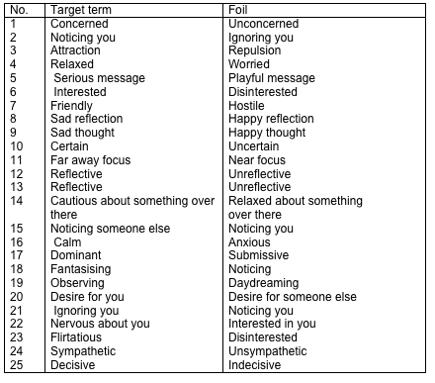The Gender Recognition Task involved looking at the same sets of eyes in the experimental task, but this time identifying the gender of the person in each photograph. This is a social judgement without involving mind reading, and allowed the researchers to check if any deficits on the Eyes Task could be attributed to general deficits in face perception, perceptual discrimination, or social perception. This also had a maximum score of 25.

The Basic Emotion Recognition Task (Emotion Task) involved judging photographs of full faces displaying the basic emotions. This was designed to check whether any deficits on the Eyes Task could be attributed to a deficit in basic emotion expression recognition. Six faces were used, testing the following basic emotions: happy, sad, angry, afraid, disgusted, and surprised.

In order to check the **validity** of the Eyes Task as a theory of mind task, participants in the two clinical groups (autism and Tourette syndrome) were also tested on Happe’s Strange Stories. This is known as **concurrent validity**, and is based on the assumption that two measures of the same thing should produce similar results. The Eyes Task, the Strange Stories and two control tasks were presented in random order to all subjects; this was to avoid order effects.

**Participants were tested individually in quiet room in their own home, in the researchers’ clinic or in the laboratory at the university.**

**Data collection**

* Quantitative: number of correct responses out of 25 on the Eyes Task (also, number of correct responses in the control tests: gender of eyes and basic emotion test)
* Qualitative: participants were asked to give reasons for how characters behaved in Happe’s Strange Stories Task

**Results**

Adults with autism were less likely to identify the **Target foil** than the other two groups:

* Condition Mean score on the Eye Task
* Adults with autism 16.3
* ‘Normal’ adults 20.3
* Adults with Tourette syndrome 20.4

Normal females were better at reading minds from eyes than normal males.

* Condition Mean score on the Eye Task
* ‘Normal’ males 18.8
* ‘Normal’ females 21.8

On the Strange Stories Task none of the participants with Tourette syndrome made any mistakes whereas many of those participants with autism did. On the Gender and Emotion Control Tasks, there were no differences between the groups.

**Conclusions**

* Baron-Cohen concluded that the results of this study provide evidence for subtle ‘mindreading’ deficits in intelligent adults on the Autistic spectrum. Therefore the core deficit involved in autism is the lack of an advanced theory of mind.
* The eye task is a ‘pure theory of mind test’ for adults because there is NO context (does not require an understanding of what the person whose eyes are shown is ‘doing’.)
* Females have more advanced theory of mind skills than males, supporting the idea that the male brain predisposes some individuals to developing autism

**Evaluation**

**Strengths**

* Experiment has high control over variables such as intelligence, sex and developmental disorders. Therefore the findings are high in validity as the researchers ensured that the independent variable which is the characteristics of autism was causing the dependent variable that is performance on the Eye Task.
* Experiment is high in reliability as the procedure was standardised - every participant was tested in the same way, for example the way the photographs were presented.
* Quasi-experiments tend to be high in ecological validity as the IV is naturally occurring therefore findings are more true to real life.
* Collection of both quantitative and qualitative data allows for statistical comparisons between scores as well as rich insight into their decision making processes thus providing a more holistic understanding of the phenomena being studied.
* The Eyes task is high in validity because the target terms also consisted of cognitive mental states, not simply emotions. This is therefore more than just an emotion perception test. Also, performance on the Eyes task was equivalent to performance on the Happe’s Strange Stories Task (so there was concurrent validity). Contrastingly, performance on the Eyes task was not equivalent to that on the control tasks suggesting that the poor performance by participants with autism was not due to a deficit in extracting social information from minimal cues.

**Weaknesses**

* The ‘Eyes task’ lacks ecological validity and thus findings may not generalise to real life situations. In real life we have to interpret emotions from full faces, people’s body language, in real social situations as opposed to examining static images of eyes. Also, the artificial lab setting may have affected participant’s performance.
* The Eyes Task may lack validity, because participant’s had only one of two mental state options to choose from and only 3 seconds to examine a static image of eyes and make their decisions in a lab context.
* The quantitative may have lacked reliability because there were different numbers of people in each group therefore the mean can become unreliable.
* Quasi-experiments tend to have less control over extraneous variables, e.g. any potential individual differences in the severity of diagnosed conditions, and therefore we cannot clearly establish cause and effect because the IV is not directly controlled.
* The sample is unrepresentative of the target population because the people with Autism had no other disorder or mental problems – most people with Autism have other problems as well as the autism. Also the sample size was small which may not have masked the effect of individual differences meaning the findings may lack generalisability.

Past Paper and Exam Style Questions

Explain the term ‘quasi experiment’ in relation to this study. [4]

__________________________________________________________________________________________________________________________________________________________________________________________________________________________________________________________________________________________________________________________________________________________________________________________________________________________________________________________________

Write a directional hypothesis for this study. [3]

__________________________________________________________________________________________________________________________________________________________________________________________________________________________________________________________________________________________________________________________________________________________________________________________________________________________________________________________________

Outline two of the ways the participants were tested. [4]

__________________________________________________________________________________________________________________________________________________________________________________________________________________________________________________________________________________________________________________________________________________________________________________________________________________________________________________________________

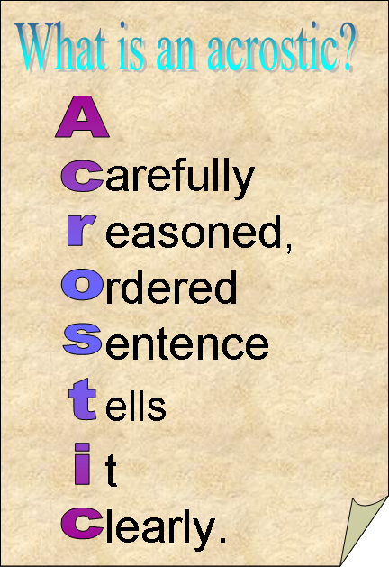Acrostic

Name _________________________ Create an acrostic of key words for Baron-Cohen and Autism

B ____________________

A ____________________

R ____________________

O ____________________

N ____________________

C ____________________

O ____________________

H ____________________

E ____________________

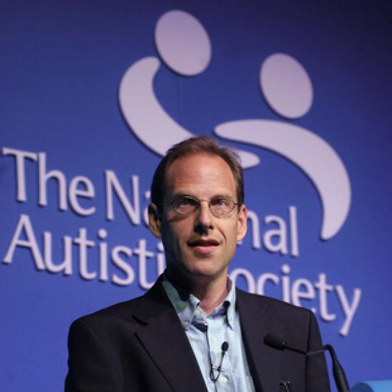N ____________________

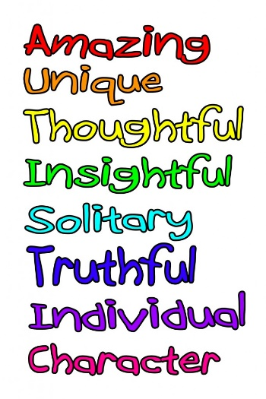

A ____________________

U ____________________

T ____________________

I ____________________

S ____________________

M ____________________

****Maths Focus

**Mean Score on the Eyes Task (Out of 25)**

1. Autism/AS Group – 16.3 (Range: 13 – 23)
2. ‘Normal’ Adults – 20.3 (Range: 16 – 25)
3. Tourettes Group – 20.4 (Range: 16 – 25)

Normal males and Females mean scores on the eyes task

1. Males – 18.8 (Range: 16 – 22)
2. Females – 21.8 (Range: 20 – 25)

Calculate the **percentage scores to 2 significant figures**

**Mean Score on the Eyes Task (Out of 25)**

1. Autism/AS Group =
2. ‘Normal’ Adults =
3. Tourettes Group =

Normal males and Females mean scores on the eyes task

1. Males =
2. Females =

Identify which **level of data** the results are in:

Nominal / ordinal / interval

Identify and explain which inferential statistical test would be used:

Test = _________________________________________________________Because it is:

* + - * A test of difference / relationship
      * Independent / repeated measures
      * Nominal / interval level data

Baron Cohen collected

qualitative / quantitative data

The data collected was

primary / secondary

1. Which one of the following groups of Ps were not studied in the experiment?

1. Ps with autism
2. 'Normal' adults
3. Ps with Tourette syndrome
4. Participants with Down's syndrome

2. Which one of the following is not a symptom of autism?

1. Difficulties with social interaction
2. Difficulties with verbal communication
3. Difficulties with non-verbal communication
4. Imaginative impairments
5. A restricted range of activities and interests
6. A lack of obsessive tendencies

3. According to Baron-Cohen having a theory of mind enables an individual to …

1. Conserve
2. See what another individual can see
3. Appreciate that other people have different thoughts to themselves
4. Recognise the gender of a face

4. The main dependent variable in the experiment was

1. The three groups of participants
2. The types of participants used
3. Performance on the eyes task
4. Autism

5. The main independent variable in the experiment was

1. The three groups of participants – participants with high functioning autism, ‘normal’ participants and participants with Tourette syndrome.
2. The two groups of participants – Ps with high functioning autism and ‘normal’ Ps
3. Participants with Tourette syndrome and participant without Tourette syndrome
4. The performance on the advanced test of theory of mind (eyes task).

6. Autism is

1. A life-long condition
2. Caused by poor parenting
3. Not long lasting
4. None of the above

7. Which design did this study use?

1. A correlational design
2. A matched pairs design
3. A repeated measures design
4. An independent measures design

8. Why is this experiment an example of a quasi or natural experiment?

1. It was a snapshot study so it is a natural experiment
2. It was not a real study so it is a natural experiment
3. The participants could not be randomly assigned to the groups
4. The participants were in their natural environment
5. The participants were not matched

9. What did the study find?

1. ‘Normal’ adult females had more difficulties with the Eye Task than ‘normal’ adult males.
2. Adults with autism had difficulties with the basic emotion task.
3. Adults with autism had difficulties with the gender control task.
4. High functioning adults with autism had more difficulties with the Eye Task than both ‘normal’ adults and adults with Tourette syndrome.

10. Which one of the following statements about the basic emotion recognition task is correct?

1. Judging photographs of whole faces displaying 6 basic emotions.
2. Participants with autism struggled on the emotion task

11. What are findings from studies into theory of mind tasks BEFORE Baron Cohen?

1. Adults with autism can pass theory of mind tasks
2. Adults with autism cannot pass theory of mind tasks
3. Adults with Tourette syndrome cannot pass theory of mind tasks
4. Children with autism can pass theory of mind tasks

12. Which of the following tasks test for an advanced theory of mind?

1. Basic emotion task
2. Gender recognition task
3. IQ tests
4. The eyes task

13 Which of the following tasks test for an advanced theory of mind in very young children?

1. Basic emotion task
2. Gender recognition task
3. Sally Anne test
4. Strange stories task

14 Which of the following tasks test for an advanced theory of mind in young children?

1. Basic emotion task
2. Gender recognition task
3. Sally Anne test
4. Strange stories task

15. Which test was used to confirm the validity of the Eyes Task?

1. Basic emotion task
2. Gender recognition task
3. IQ test
4. Sally Anne test
5. Strange stories task

16. Which one of the following results is correct?

1. 'Normal' adult males scored higher on the Eye task than 'normal' adult females.
2. 'Normal' adults scored significantly better on the eyes task than Ps with Tourette.
3. There was little difference between the performance of participants with Tourette syndrome and 'normal' adults on the eyes task.
4. There was little difference in the performance of participants with autism and participants with Tourette syndrome on the eyes task

17. Why did the researchers also test adults with Tourette syndrome?

1. Both are believed to be associated with abnormalities in the frontal region of the brain
2. Neither autism or Tourette syndrome disrupt schooling or peer relations
3. The causes of autism are thought to be very different to Tourette syndrome
4. Tourette syndrome is nothing like autism

18. Which of the following words is the foil (opposing word presented with the correct answer) to the target word 'friendly'.

1. anxious
2. hostile
3. repulsive
4. submissive
5. uncertain
6. worried

Write the questions for the following answers:

1. IV is the type of participant (autism/Tourette/’normal’); DV is their success in the Eyes Task.
2. The IV affected to what extent they were able to identify the emotions in the Eyes Task: the autism group had a mean score of 16.3, the Tourette group 20.4 and the ‘normal’ group 20.3.
3. One group consisted of 16 participants who had high-functioning autism, and had normal intelligence (13m, 3f). Another group consisted of 10 adult patients with Tourette syndrome (8m, 2f).
4. The Eyes Task required participants to view black and white photographs of the eye region of 25 different faces for 3 seconds and then identify what emotion the person was feeling, from a choice of two.
5. The Tourette group was more successful on average than the autism group at identifying emotions from the pictures of eyes.
6. A ‘ceiling effect’ is when a task is so easy that all or most of the respondents achieve maximum marks.
7. In this study there was no ceiling effect because there was a good range of correct answers and most people did not identify all the emotions correctly.
8. The difference in the number of correctly identified emotions between the autism group and the control group suggests that people with autism cannot read the emotion in people’s faces as successfully as ‘normal’ people, implying that they have difficulty in making assumptions about what other people are feeling. This is a lack a ‘Theory of Mind’.
9. It is low in ecological validity because in real life people with autism would have an entire situation to help them make assumptions about what people are thinking and feeling and would not just be reliant upon a still photograph with no context. Secondly they would normally be seeing a whole, mobile face so the mouth and movements would provide additional clues to help them identify the emotion someone was feeling.
10. The Tourette group was more successful on average than the autism group at identifying emotions from the pictures of eyes.
11. ‘Concerned’ and ‘unconcerned’.
12. The Eyes Task was standardised by showing photographs that were all the same in that they were the same size and showing the region of the face from mid-nose to eyebrows.
13. One other task was the Gender Recognition of Eyes task, which required participants to identify the gender of the people in the Eyes Task photos.
14. Two control groups were the ‘normal’ group and the group of people with Tourette syndrome.
15. To provide a baseline for comparison; to see whether the people with autism performed worse, better or the same as ‘normal’ participants, or the same, better or worse than a group of people with another condition which may have affected their social relationships.
16. Theory of Mind was measured by assessing how many correct answers were given by the participants in a test of emotion recognition from photos of eyes.

|  |
| --- |
| Describe one of the control tasks used in Baron Cohen’s study. [2] |
| Describe two of the groups used in Baron Cohen’s study. [4] |
| Did Baron Cohen’s Eyes task have a ceiling effect? Explain your answer. [3] |
| Explain how the Eyes task was standardised to ensure reliability. [2] |
| Explain how Theory of Mind was operationalised in Baron Cohen’s study. [2] |
| Explain two reasons why the Eyes task lacks validity. [4] |
| Explain why is meant by the ‘ceiling effect’. [2] |
| Explain why the two control groups used in Baron Cohen’s study. [3] |
| Identify one difference between the performance of the autism group and the Tourette group. [1] (Q5 / Q10) |
| Identify one difference between the performance of the autism group and the Tourette group. [1] (Q5 / Q10) |
| Identify one target and one foil word used in the Eyes task. [2] |
| Identify the IV and the DV in the Eyes task. [2] |
| Identify the two control groups used in Baron Cohen’s study. [2] |
| Outline one conclusion from the Eyes task. [2] |
| Outline one conclusion which can be drawn from Baron Cohen’s study. [4] |
| Outline the procedure of the Eyes task. [4] |

Baron-Cohen, Leslie and Frith.(1985) Does the autistic child have a theory of mind?

Thinking like a Psychologist - Evaluating the Core Study

**What are the strengths and weaknesses of the method used in this Study?**

This study used a quasi-experimental design. This is a design where the researcher does not have control over the independent variable but takes advantage of conditions where the different conditions of the independent variable occur naturally. In this study, the researchers could not randomly allocate people to the three groups but had to find autistic, Down’s syndrome and developmentally normal children who were able to take part in the research. Quasi experimental designs are useful as they allow researchers to investigate naturally occurring variables that can’t be manipulated experimentally but they lack some of the control of laboratory experiments. It is possible that there are other differences between the groups of participants which are unrelated to the variables being studied.

**What type of data is collected in the study?**

The data is quantitative as it is simply numbers of children that got the belief question correct. This is appropriate data to collect in this study as the researchers were simply proposing that more autistic children would get this question wrong. However, it would have been possible to explore the children’s answers further (perhaps with some open ended questions such as ‘why will Sally look there?’) which would generate qualitative data. However, this would depend on the language skills of the children being tested.

**How ecologically valid is the study?**

It is possible to criticise the ecological validity of the study in one important respect.

In everyday life, we do not attribute thoughts and beliefs to dolls but to other people. Why did the researchers choose to explore theory of mind in this way? If autistic children cannot attribute beliefs to dolls, this does not necessarily mean that they can’t attribute beliefs to people. However, Leslie and Frith (1988) replicated the procedure used in the Sally Anne task with real people and found similar results, suggesting that the Sally Anne task is a valid one and can be generalised to attributing beliefs to other people.

The use of dolls may be criticised in other ways. Some of the children in this study were eleven years old or more and if the figures quoted earlier are correct, the majority of the autistic children are likely to have been boys. It may be that ‘playing with dolls’ is not a particularly appropriate task for these children. It can also be argued that using real people in this task is more appropriate than using dolls particularly with autistic children who are highly unlikely to play with dolls usually.

**How useful are the results?**

There are several points to make here. Firstly there are four autistic children from the sample of twenty who did answer the belief question correctly. This does slightly weaken the conclusion drawn by the researchers that autistic children lack a theory of mind. It might be more accurate to say that most autistic children lack a theory of mind. A more detailed study of the children who did demonstrate theory of mind might be useful. If they have this ability and are still demonstrating the triad of impairments outlined earlier, then the lack of theory of mind cannot be the ‘crucial ingredient’ for autism that has been implied.

On a more positive note, there is no doubt that a lack of theory of mind is common in autistic individuals. Now that this has been established, it may be possible to develop teaching methods that attempt to encourage theory of mind skills in autistic individuals. For example, many autistic children are unable to recognise emotions from facial expressions in the same way that non autistic individuals do (this is another manifestation of lacking a theory of mind) but can learn to interpret expressions with practice.

|  |  |  |  |  |  |  |  |  |  |  |  |  |  |  |  |  |  |
| --- | --- | --- | --- | --- | --- | --- | --- | --- | --- | --- | --- | --- | --- | --- | --- | --- | --- |
| P | F | B | U | H | S | E | T | T | E | R | U | O | T | D | R | E | T |
| T | F | K | A | L | O | P | M | E | N | T | S | M | L | G | F | G | H |
| S | O | I | R | E | S | P | E | C | T | R | U | M | E | C | A | F | Y |
| D | R | N | E | D | P | X | Q | Z | U | L | O | J | O | J | J | T | V |
| L | C | D | A | E | A | P | V | R | A | I | H | N | I | Q | L | R | X |
| I | E | R | S | T | R | G | A | G | H | E | C | O | P | H | T | O | S |
| M | D | T | A | F | E | K | B | H | U | U | D | P | T | I | D | U | E |
| I | C | P | L | A | I | M | A | B | R | P | E | I | L | U | N | J | C |
| T | H | L | L | L | N | D | R | R | G | O | C | S | I | L | I | L | A |
| E | O | O | Y | G | M | H | E | I | K | I | F | A | L | P | M | S | W |
| D | I | U | A | T | F | N | S | A | F | A | N | S | M | F | F | C | J |
| C | C | V | N | I | T | S | I | E | S | L | F | T | H | N | O | E | E |
| R | E | O | N | N | O | K | D | A | H | E | D | H | G | E | Y | K | A |
| A | N | I | E | E | X | E | M | S | I | T | U | A | I | R | R | P | K |
| S | I | R | U | X | R | Q | U | E | S | T | E | N | N | T | O | G | N |
| E | R | T | G | O | R | E | T | S | A | F | T | E | E | Q | E | N | O |
| S | G | E | C | B | L | I | N | D | E | R | G | S | B | U | H | R | P |
| F | A | L | T | Y | U | P | I | H | C | Q | F | T | H | U | T | M | O |
| F | A | L | S | E | B | E | L | I | E | F | N | S | K | H | E | A | N |

1. 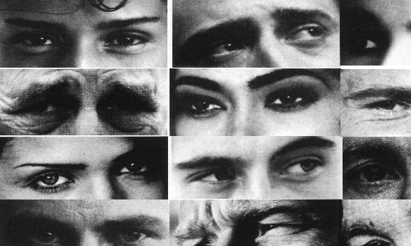Author of the strange stories
2. Disorder investigated by Baron-Cohen
3. Disorder used as comparison group by Baron-Cohen
4. Ability to understand that others have different thoughts/feelings/attitudes to our own
5. Both the strange stores and the dolls task are examples of these
6. 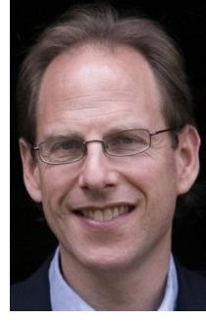Type of validity where two tests are compared to see if they give the same results
7. Where participants are given two or more possible answers in a questionnaire and they have to select one.
8. The single most likely reason/explanation for the symptoms of autism
9. A range of disorders all previously connected to Autism
10. Task used with children to check for Theory of Mind, unsuitable to use with adults.

Evaluating Baron Cohen

|  |  |  |
| --- | --- | --- |
| **Ethics** | **How the study is ethical and why** | **How the study is unethical and why** |
| Definition: |  |  |
|  | | |
| **Validity** | **How the study is valid and why** | **How the study is invalid and why** |
| Definition: |  |  |
|  | | |
| **Reliability** | **How the study is reliable and why** | **How the study is unreliable and why** |
| Definition: |  |  |
|  | | |
| **Ethnocentrism** | **How the study is ethnocentric** | **How the study is cross-cultural** |
| Definition: |  |  |
|  | | |
| **Sampling Bias** | **How the sampling method doesn’t have bias** | **How the sampling method has bias** |
| Definition: |  |  |

Paper 2 Section C Style Questions

When Stacey went over to her new friend Chelsea’s house, she met Chelsea’s four year-old brother, Shawn. “Hi,” said Stacey, smiling. Shawn looked at her but didn’t say anything. Then he turned back to a toy he was holding. Later, in Chelsea’s room, Stacey said, “I don’t think your brother likes me.”

“It’s not your fault,” said Chelsea. “It’s not that he doesn’t like you — Shawn has autism and it’s hard for him to talk sometimes. But I can show you how to play with him, if you want.”

1. Identify **one** psychological issue raised by the above source. Support your answer with evidence from the source. [3]

*The first thing to do is to highlight the key words and phrases that could be evidence of a particular area, key theme or psychological theory. For example you could highlight* ***Shawn has autism and it’s hard for him to talk sometimes*** *as this suggests that Shawn lacks a theory of mind and has a triad of impairments. Similarly, this could be supported by* ***Shawn looked at her but didn’t say anything*** *after Stacey said “Hi” and smiled at him.*

1. **Outline psychological research and how it relates to the issue you have identified [6]**

*Your task now is to describe the psychological research that supports the issue identified from the PALS using the highlighted evidence, for example using the Baron- Cohen et al. (1997) study you could explain that a* ***lack of theory of mind*** *means it is difficult for individuals with autism to understand social situations and how to interact due to the triad of impairments.*

1. **Explain how the situation could be managed by Chelsea and Shawn. [6]**

*Courses and advice is given by the National Autistic Society such as ‘how can I start a conversation’. Here people are given suggestions such as* ***approach*** *the person but stop when you are about an arm’s length away and face them and then say “hello”. Similarly parents can be* ***coached*** *to understand how to help their children so that they can overcome difficulties when communicating with their child.*

1. **Evaluate your suggestions in Q3. [10]**

*The suggestion that parents can be* ***coached*** *to help their child’s communication skills may be more effective for some parents more than others; it is dependent on parenting skills and may not bring immediate or even long lasting results.* ***Improved communication*** *also depends on consistency of attendance at the course and practising the skills which will be difficult for both people with autism and their parents. It may also be difficult to get a* ***diagnosis*** *of autism that allows access to these courses.*

|  |  |  |
| --- | --- | --- |
| Freud | Individual Differences | Baron Cohen |
| Differences | Similarities | Differences |
| Individual differences because it explains why people differ, such as having a phobia. It also considers how all people are similar - how the Oedipus (and Electra) complexes are a part of normal development. | **Area: Individual Differences**  Behaviour is caused by different things for each person, as everyone is different and unique | Individual differences because it explains why people differ, such as having Autism due to differences in people's Theory of Mind. |
| Case study focussing on the Oedipus Complex of Little Hans and the development of phobias. | **Key Theme: Understanding Disorders**  What we understand about psychological and mental health disorders | Investigated the theory of mind in high-functioning adults with autism. |
| Methodological Issues | | |
| * Longitudinal case study * Data collected through self-reports with father Max Graf - secondary data | **Research Method / Design** | * Natural experiment * IVs = autism, Tourette's, normal * Matched pairs design (trios) |
| Single male: five year old boy, whose father was a fan of Freud’s work. Highly unrepresentative; unwise to attempt to generalise findings. | **Sampling Technique/Sample**   * Restricted samples * Ethnocentric | * 16 Ps with Autism (13M, 3F) * 10 Ps with Tourette's (8M, 2F). * Both these groups had passed 1st order ToM tests (basic emotion test, gender recognition, Sally Ann tests / Happe's Strange Stories) * 50 'normal' Ps (25M, 25F) |
| Qualitative data | **Data** | Quantitative data |
| * Not replicable * Not standardised | **Reliability** | ☺ Pictures standardised - all 15 x 10cm shown for 3 seconds, same conditions, standardised instructions ☺ **Inter-rater reliability** – judges checked word pair choices for each of the Eyes |
|  | **Validity** | ☺ **Concurrent validity** – compared Eyes task to Happe’s Strange Stories  ☹ The Eyes Task lacks mundane realism, so results may lack **ecological validity** |
| Practical Applications | | |
| **Psychoanalysis:** using dream analysis, free association, Rorscach inblots, Thematic Apperception Tests | Methods to understand and treat disorders - useful for training therapists | Use of images to train people with autism to understand emotions |
| To what extent the contemporary study changes our understanding of the key theme | | |
| To a greater extent.  Baron Cohen changes the way psychologists ‘understand disorders’, by giving a cognitive explanation of disorders (lack of theory of mind causing autism) and an objective way of measuring this (the Eyes Task), rather than a psychodynamic explanation of mental illness (Freud – phobias due to fixation at the anal stage as part of the 5psychosexual stages) and a subjective way of measuring this (psychoanalysis using dream analysis). | | |
| To what extent the contemporary study changes our understanding of … diversity | | |
| Individual diversity | Social diversity | Cultural diversity |
| Both studies develop an understanding of why behaviour may differ among people. Baron-Cohen - lack of ToM leads to changes in behaviour over a lifetime; Freud - why some experience phobias for a shorter period of time |  | Baron Cohen’s study was carried out in the UK and suggests that autism can be explained in the same way (lack of ToM) across other cultures however, like Freud, this research only focused on one culture (Austria). |

Assumptions of the Individual Differences Approach

* Individuals differ in their behaviour and personal qualities so not everyone can be considered ‘the average person’.
* Every individual is genetically unique and this uniqueness is displayed through their behaviour. So everyone behaves differently.
* All human characteristics can be measured from one person and quantified. The measures gained from one person are different to those gained from another.
* All psychological characteristics are inherited and as everyone inherits different characteristics, everyone is different and unique.

1. How does the study apply to the key theme of ‘understanding disorders’? [2]
2. How does the study apply to the area of ‘individual differences’? [4]
3. Explain one similarity and one difference between Baron-Cohen’s study and Freud’s study. [6]
4. How does the study change our understanding of individual, social and cultural diversity?

Case Study Confidentiality Control Debrief Ecological validity Independent measures

Informed consent Inter-rater reliability Longitudinal study Natural experiment Nominal data Opportunity sampling

Ordinal / interval data Primary data Qualitative data Quantitative data Replicable Right to withdraw

Scientific Secondary data Self-selecting (volunteer) sample Snapshot study Unscientific Useful (therapy / intervention)

Paper 2 Section C Style Questions

When Stacey went over to her new friend Chelsea’s house, she met Chelsea’s four year-old brother, Shawn. “Hi,” said Stacey, smiling. Shawn looked at her but didn’t say anything. Then he turned back to a toy he was holding. Later, in Chelsea’s room, Stacey said, “I don’t think your brother likes me.”

“It’s not your fault,” said Chelsea. “It’s not that he doesn’t like you — Shawn has autism and it’s hard for him to talk sometimes. But I can show you how to play with him, if you want.”

1. Identify **one** psychological issue raised by the above source. Support your answer with evidence from the source. [3]

*The first thing to do is to highlight the key words and phrases that could be evidence of a particular area, key theme or psychological theory. For example you could highlight* ***Shawn has autism and it’s hard for him to talk sometimes*** *as this suggests that Shawn lacks a theory of mind and has a triad of impairments. Similarly, this could be supported by* ***Shawn looked at her but didn’t say anything*** *after Stacey said “Hi” and smiled at him.*

____________________________________________________________________________________________________________________________________________________________________________________________________________________________________

1. **Outline psychological research and how it relates to the issue you have identified [6]**

*Your task now is to describe the psychological research that supports the issue identified from the PALS using the highlighted evidence, for example using the Baron- Cohen et al. (1997) study you could explain that a* ***lack of theory of mind*** *means it is difficult for individuals with autism to understand social situations and how to interact due to the triad of impairments.*

_______________________________________________________________________________________________________________________________________________________________________________________________________________________________________________________________________________________________________________________________________________________________________________________________________________

___________________________________________________________________________________________________________________________________________________________________________

1. **Explain how the situation could be managed by Chelsea and Shawn. [6]**

*Courses and advice is given by the National Autistic Society such as ‘how can I start a conversation’. Here people are given suggestions such as* ***approach*** *the person but stop when you are about an arm’s length away and face them and then say “hello”. Similarly parents can be* ***coached*** *to understand how to help their children so that they can overcome difficulties when communicating with their child.*

______________________________________________________________________________________________________________________________________________________________________________________________________________________________________________________________________________________________________________________________________________________

_______________________________________________________________________________________________________________________________________________________________________________________________________________________________________________________________________________________________________________________________________________________________________________________________________________

1. **Evaluate your suggestions in Q3. [10]**

*The suggestion that parents can be* ***coached*** *to help their child’s communication skills may be more effective for some parents more than others; it is dependent on parenting skills and may not bring immediate or even long lasting results.* ***Improved communication*** *also depends on consistency of attendance at the course and practising the skills which will be difficult for both people with autism and their parents. It may also be difficult to get a* ***diagnosis*** *of autism that allows access to these courses.*

_______________________________________________________________________________________________________________________________________________________________________________________________________________________________________________________________________________________________________________________________________________________________________________________________________________

_______________________________________________________________________________________________________________________________________________________________________________________________________________________________________________________________________________________________________________________________________________________________________________________________________________

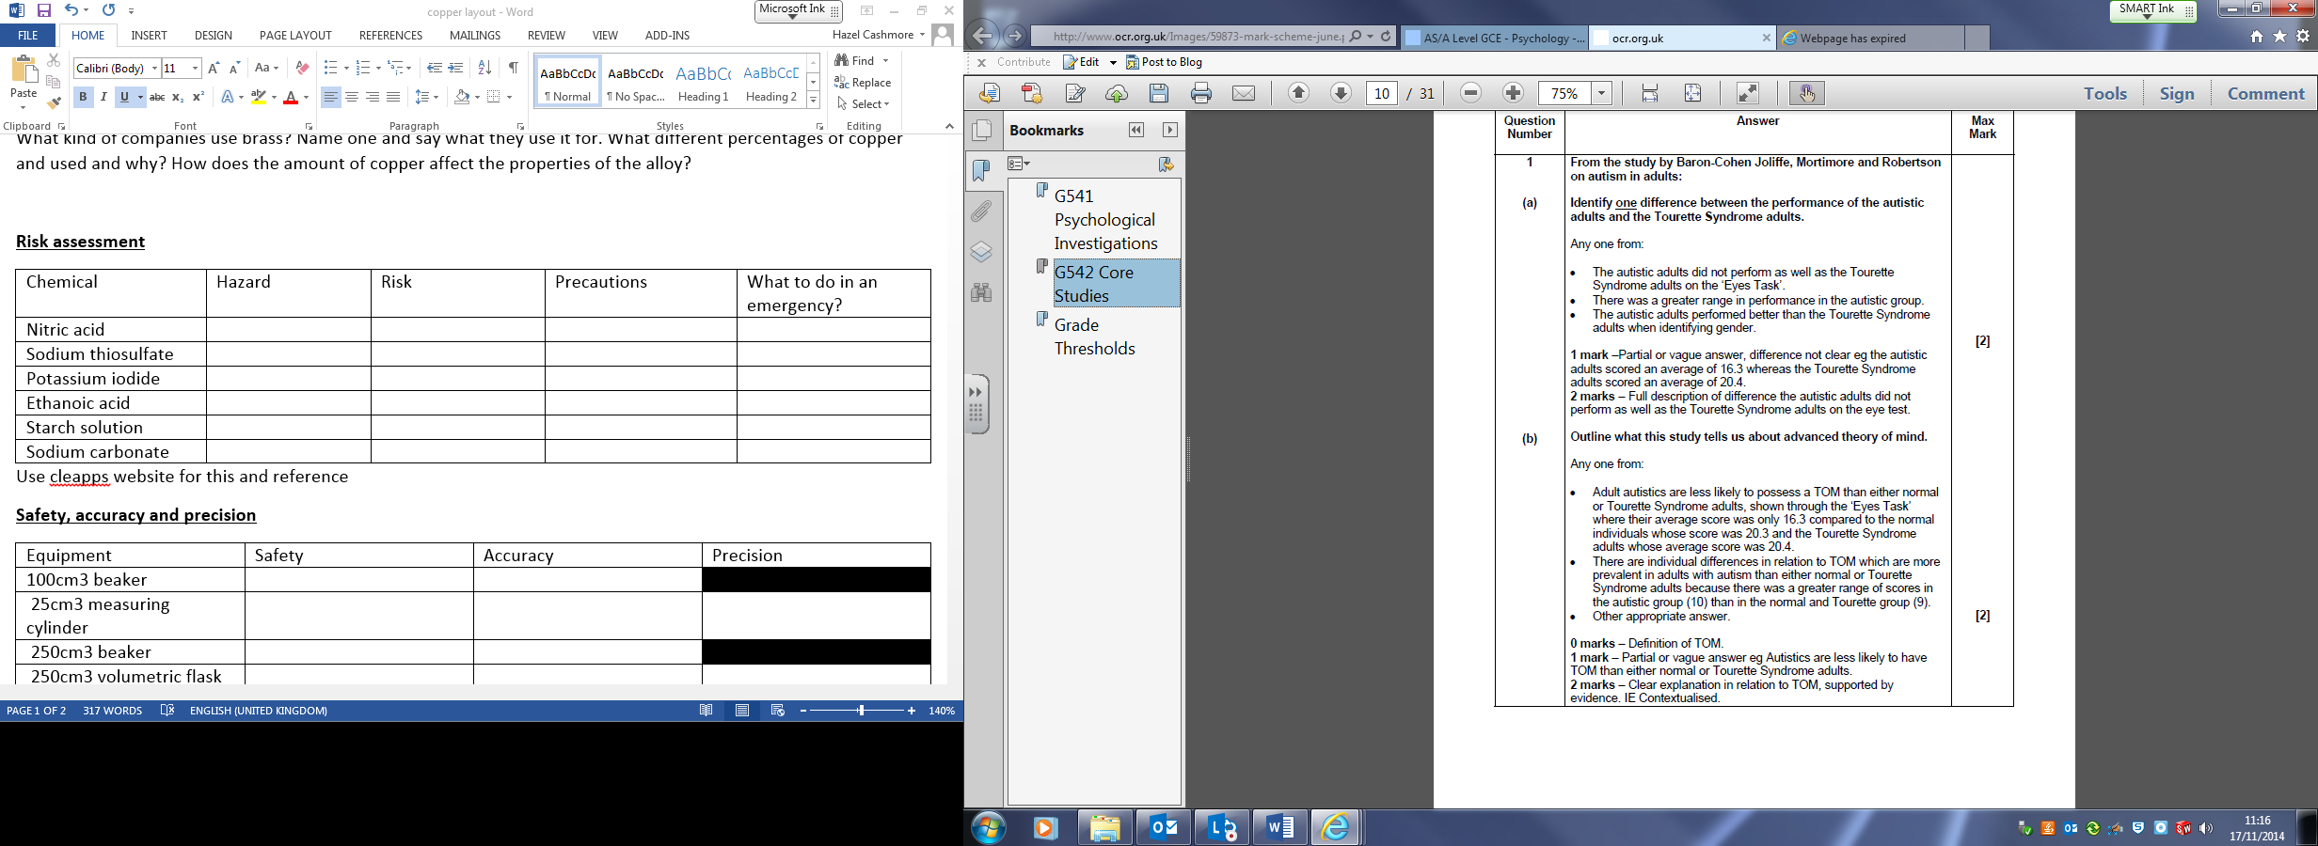

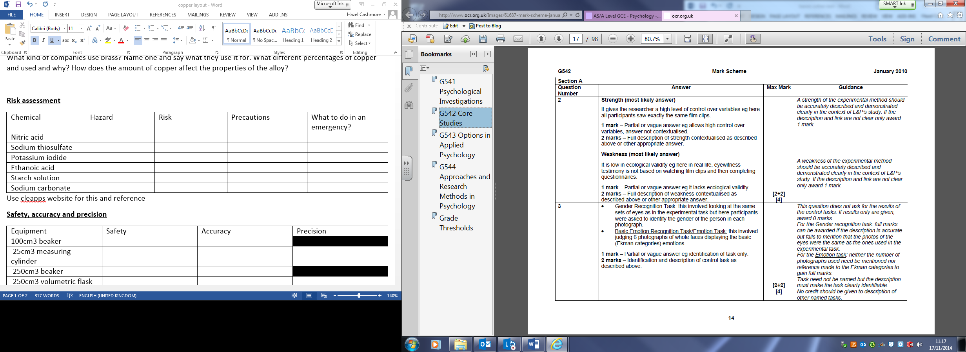

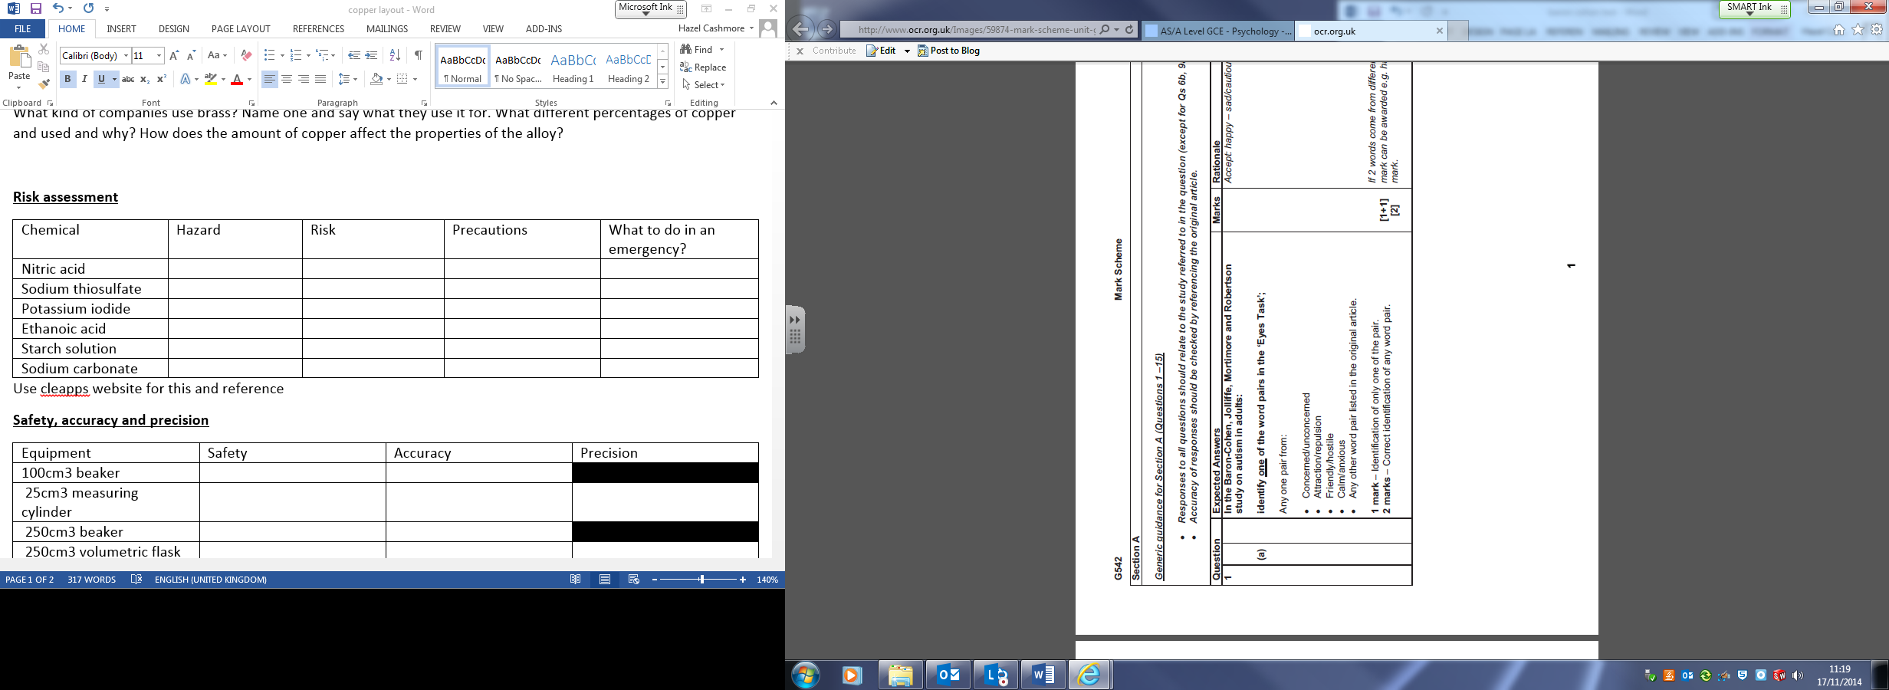

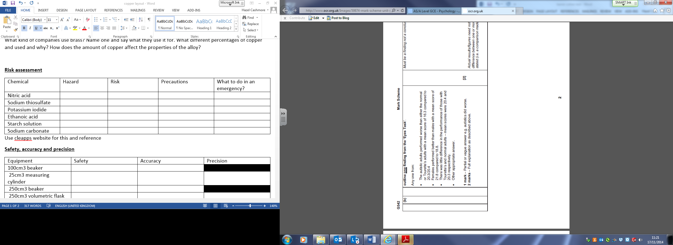

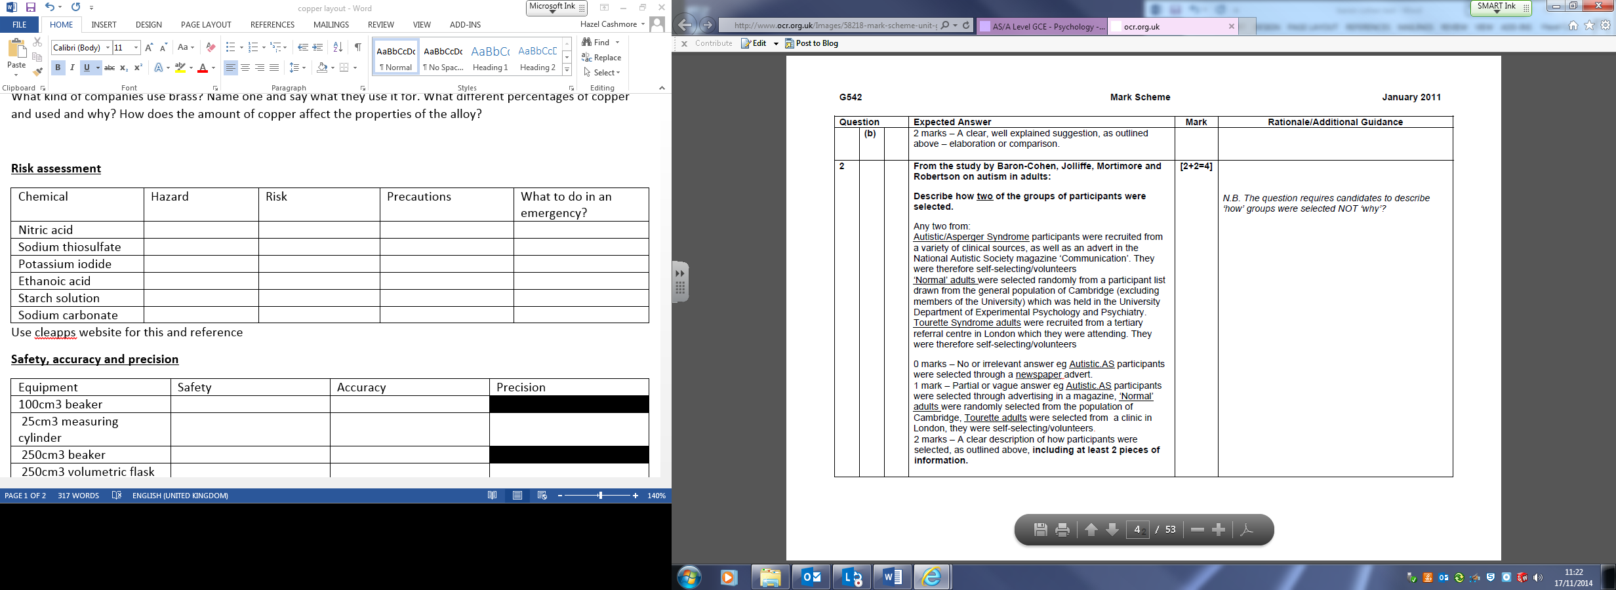

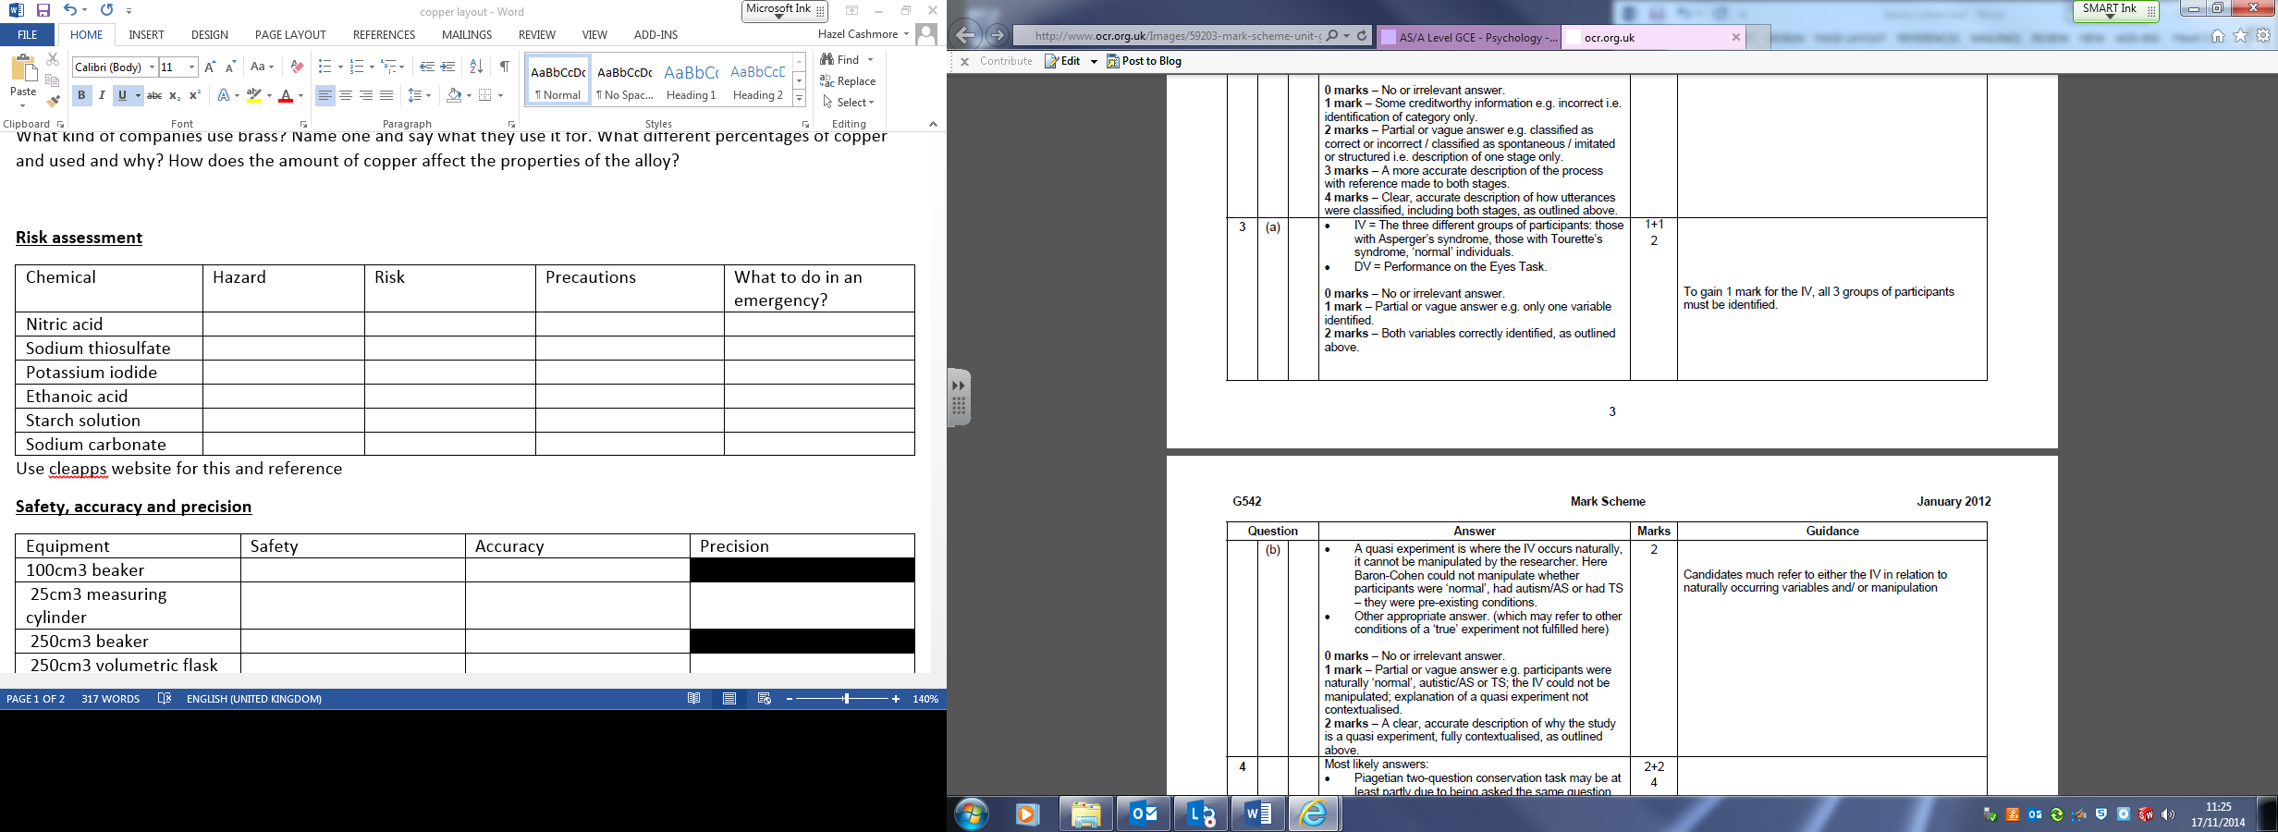



1. D
2. F
3. C
4. C
5. A
6. A
7. A
8. C
9. D
10. A
11. A
12. D
13. C
14. D
15. A
16. C
17. A
18. B

Answers

1. Identify the IV and the DV in the Eyes task. [2]
2. Outline one conclusion from the Eyes task. [2]
3. Describe two of the groups used in Baron Cohen’s study. [4]
4. Outline the procedure of the Eyes task. [4]
5. Identify one difference between the performance of the autism group and the Tourette group. [1]
6. Explain why is meant by the ‘ceiling effect’. [2]
7. Did Baron Cohen’s Eyes task have a ceiling effect? Explain your answer. [3]
8. Outline one conclusion which can be drawn from Baron Cohen’s study. [4]
9. Explain two reasons why the Eyes task lacks validity. [4]
10. Identify one difference between the performance of the autism group and the Tourette group. [1]
11. Identify one target and one foil word used in the Eyes task. [2]
12. Explain how the Eyes task was standardised to ensure reliability. [2]
13. Describe one of the control tasks used in Baron Cohen’s study. [2]
14. Identify the two control groups used in Baron Cohen’s study. [2]
15. Explain why the two control groups used in Baron Cohen’s study. [3]
16. Explain how Theory of Mind was operationalised in Baron Cohen’s study. [2]

Describe one of the control tasks used in Baron Cohen’s study. [2]

Describe two of the groups used in Baron Cohen’s study. [4]

Did Baron Cohen’s Eyes task have a ceiling effect? Explain your answer. [3]

Explain how the Eyes task was standardised to ensure reliability. [2]

Explain how Theory of Mind was operationalised in Baron Cohen’s study. [2]

Explain two reasons why the Eyes task lacks validity. [4]

Explain why is meant by the ‘ceiling effect’. [2]

Explain why the two control groups used in Baron Cohen’s study. [3]

Identify one difference between the performance of the autism group and the Tourette group. [1]

Identify one difference between the performance of the autism group and the Tourette group. [1]

Identify one target and one foil word used in the Eyes task. [2]

Identify the IV and the DV in the Eyes task. [2]

Identify the two control groups used in Baron Cohen’s study. [2]

Outline one conclusion from the Eyes task. [2]

Outline one conclusion which can be drawn from Baron Cohen’s study. [4]

Outline the procedure of the Eyes task. [4]

|  |  |  |
| --- | --- | --- |
| **Criteria** | **Typically individual differences research uses…** | **Because…** |
| Methodology |  |  |
| Data collection |  |  |
| Ethical issues |  |  |
| Sampling method |  |  |
| Sample |  |  |
| Reliability |  |  |
| Validity |  |  |